Yacht charter page https://boataffair.com/yacht-charter

Section Boataffair blog, please replace the photo with one of the following (please choose the one that looks best in terms of mboile an desktop versions):

https://drive.google.com/drive/folders/1vR3fslFFhgmZpGXh0qmUWji7ZNFn-WbE?usp=sharing

I like Family aboard or view form top the most

Now small title:
How to charter a yacht
Bigger title
Your BoatAffair Yacht Charter Guide

Link to blog: blog #90

Browse yachts by type text changes

Motor Yacht
1) First paragraph: motor yacht (not Motor Yacht).
2) Delete whole second paragraph.
3) Add new second paragraph: A motor yacht is a yacht powered by an engine,
and this type of boat is up to about 80 feet (24 meters) in length. They are
designed for leisure, and they feature multiple cabins, galleys (kitchens),
bathrooms, lounges and spacious sundecks. A motor yacht charter is
accessible and the overall cost of such a yacht charter is lower than a
superyacht charter. A yacht longer than 24 meters is generally considered a
superyacht. Find out more about our superyachts here:
https://boataffair.com/superyacht-charter (name the link: Superyacht
experience BoatAffair). All our motor yachts are crewed and can be chartered
for a week (overnight charters), and in some locations for day trips. Typical
and well-loved locations for a day charterson motor yachts are the South of
France, Portofino in Italy, Puerto Vallarta in Mexico, Ibiza and Mallorca,
Switzerland on Lake Lucerne and Lake Geneva, or Marbella in Spain.
4) Delete rest of the text (third, fourth and fifth, sixth paragraph).
5) Add new paragraph instead: A motor yacht is designed for comfort, pleasure,
performance and speed. This type of yacht is certain to impress, and they are
the ideal vessel for a romantic getaway, a marriage proposal, sunset dinners,
a private vacation or a day charter in style. Guests will feel pampered and
always looked after, as our professional crew will look after them during the
entire cruise.

Catamaran
1) One first line: BoatAffair works closely (capital “A”), add “s” to write works (not
work)
2) Second title “What type of boating holidays are Catamarans best suited to?”
Capital “C” for Catamaran, and change font to the font of first title
3) In the second paragraph, write “While a sailing catamaran comes with sails
and may rely on wind power to move in the water….”
4) In the second paragraph, write “ – from 45ft catamarans, up to…” (delete fairly
democratic, and add “s” to write catamarans)
5) Delete last sentence: “Find out how to charter a catamaran using Boataffair’s
simple 3 step process.”
6) Add last sentence. Find out more about catamarans at the following article:
https://boataffair.com/blog/what-is-a-catamaran (name the link: What is a
Catamaran)

Superyacht
1) At BoatAffair (capital “A”)
2) How much does it cost to charter a Superyacht (capital “S” for the word
Superyacht)

Individual Yacht Charter Pages (mobile and desktop):

On the right hand side there is a mistake: there is duplication of the charter rates (low/high…) – we only need it once, just like we used to have it before.

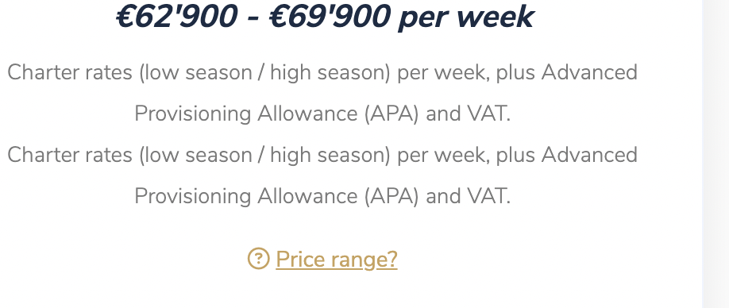

Enquiry Page (registering an account, logging in, confirmation code etc) – the lines and checkboxes are missing – please add

The little icon of the browser window

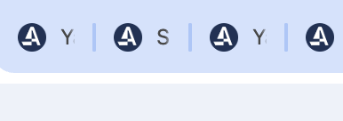

Can we change to the new Logo icon please 
Files can be found here:
https://drive.google.com/drive/folders/1r-NCdi_aKYsx6pPMqve-QCiVhV9ZDLv2?usp=sharing

Whatsapp floating button:

All pages to show floating whatsapp button linking to the whatsapp number
+ 41 788992945

Asia Pacific ONLY to link to whatsapp number +44 7400 620180

SEARCH RESULTS PAGES – across of of the search result pages (irrespective of the filters used):

At the end we are missing the little block

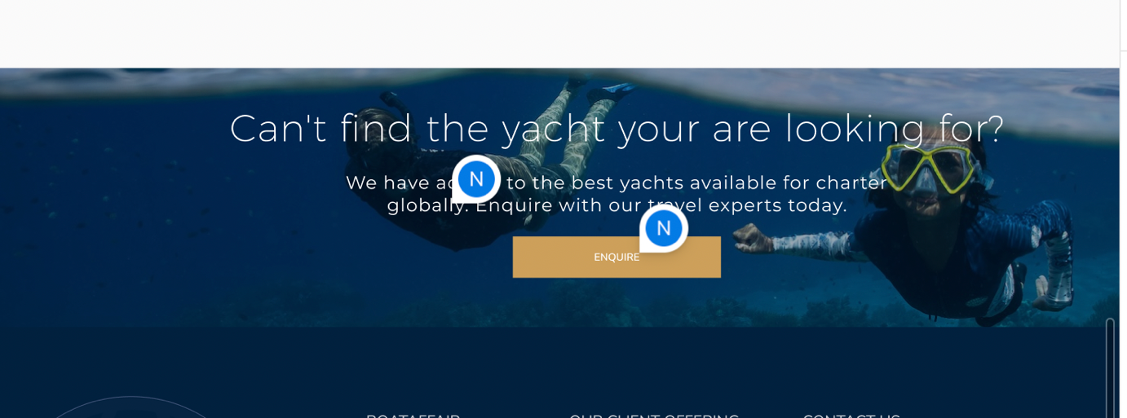

Functionality NOTIFICATIONS:

Currently notifications are disconnected. Both from enquiry form and the POP up form.

All notifications are sent from seagull@boataffair.com

Also, there are notifications we send out to users – can you please find out which ones we have now, I need to review. As far as I know we had a list of them pre-set according to the actions taken by a user

MOBILE V

Asia Pacific looks a little wonky.

EG: Header and logo look much smaller than the rest of the site, the texts at the start also look very small in comparison

Then we have yacht previews and then we have some weird design come up under see below screenshots

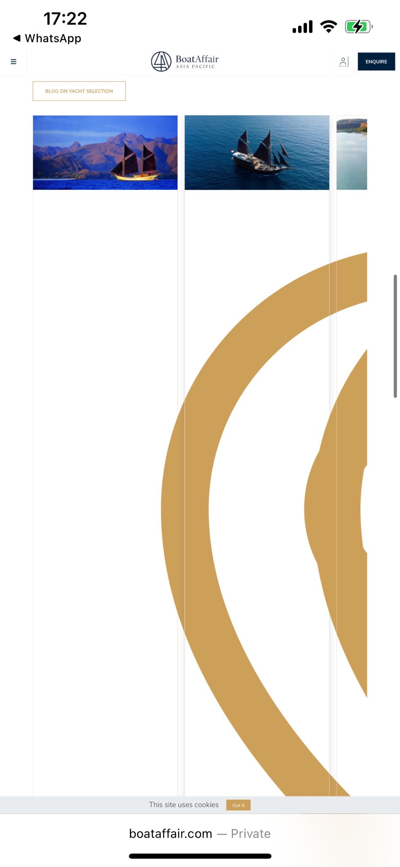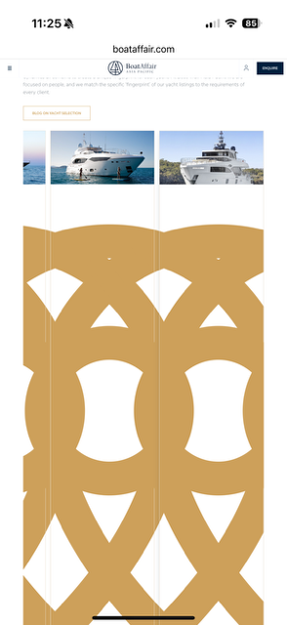

Header looks v small and the first title over the text does not look formatted

Can we please check styles again, something is now showing up correctly
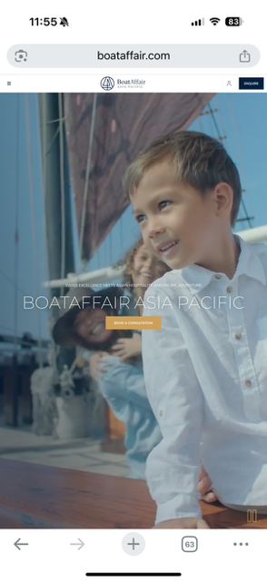

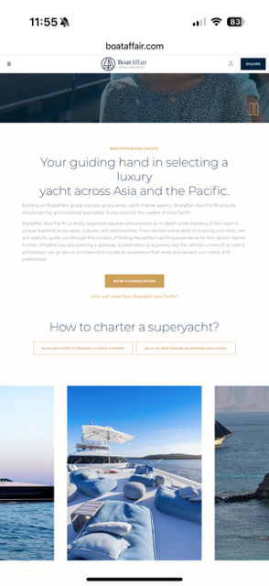

THE WHOLW SITE MOBILE V

Mobile version Enquiry/registration etc page looks super wonky still and again lines and checkboxes are missing fully. We need to make sure its all straighted out with lines, correct font sizes, and that you can see the checkboxes correctly (especially the ) accept terms of use and privacy policy). Please see screenshots below:

