Tank Systems for Refrigerated Liquefied Gas Storage

API STANDARD 625
FIRST EDITION, AUGUST 2010
ADDENDUM 1, JULY 2013
ADDENDUM 2, NOVEMBER 2014
ADDENDUM 3, JUNE 2018
ADDENDUM 4, AUGUST 2021
ADDENDUM 5, FEBRUARY 2025


American Petrofe um Institute

Licensed copy: Pierre Meurgey - ECOMM0018177 - Company: n/a. Version correct as of 11/10/2025

Special Notes

API publications necessarily address problems of a general nature. \/\/ith respect to particular circumstances, local, state, and federal laws and regulations should be reviewed. The use of API publications is voluntary. In some cases, third parties or authorities having jurisdiction may choose to incorporate API standards by reference and may mandate compliance.

Neither API nor any of APl's employees, subcontractors, consultants, committees, or other assignees make any warranty or representation, either express or implied, with respect to the accuracy, completeness, or usefulness of the information contained herein, or assume any liability or responsibility for any use, or the results of such use, of any information or process disclosed in this publication. Neither API nor any of APl's employees, subcontractors, consultants, or other assignees represent that use of this publication would not infringe upon privately owned rights.

API publications may be used by anyone desiring to do so. Every effort has been made by the Institute to ensure the accuracy and reliability of the data contained in them; however, the Institute makes no representation, warranty, or guarantee in connection with this publication and hereby expressly disclaims any liability or responsibility for loss or damage resulting from its use or for the violation of any authorities having jurisdiction with which this publication may conflict.

API publications are published to facilitate the broad availability of proven, sound engineering and operating practices. These publications are not intended to obviate the need for applying sound engineering judgment regarding when and where these publications should be used. The formulation and publication of API publications is not intended in any way to inhibit anyone from using any other practices.

Any manufacturer marking equipment or materials in conformance with the marking requirements of an API standard is solely responsible for complying with all the applicable requirements of that standard. API does not represent, warrant, or guarantee that such products do in fact conform to the applicable API standard.

All rights reserved. No part of this work may be reproduced, translated, stored in a retrieval system, or transmitted by any means, electronic, mechanical, photocopying, recording, or otherwise, without prior written permission from the publisher. Contact the Publisher, API Publishing Sen/ices, 200 Massachusetts Avenue, NW, Suite 1100, Washington, DC 20001.

Copyright O 2010, 2013, 2014, 2018 American Petroleum Institute

Foreword

Nothing contained in any API publication is to be construed as granting any right, by implication or otherwise, for the manufacture, sale, or use of any method, apparatus, or product covered by letters patent. Neither should anything contained in the publication be construed as insuring anyone against liability for infringement of letters patent.

The verbal forms used to express the provisions in this document as follows:

Shall: As used in a standard, “shall” denotes a minimum requirement in order to conform to the standard.

Should: As used in a standard, “should™ denotes a recommendation or that which is advised but not required in order to conform to the standard.

May: As used in a standard, "may" denotes a course of action permissible within the limits of a standard. Can: As used in a standard, "can" denotes a statement of possibility or capability.
This document was produced under API standardization procedures that ensure appropriate notification and participation in the developmental process and is designated as an API standard. Questions concerning the interpretation of the content of this publication or comments and questions concerning the procedures under which this publication was developed should be directed in writing to the Director of Standards, American Petroleum Institute, 200 Massachusetts Avenue, NW, Suite 1100, Washington, DC 20001. Requests for permission to reproduce or translate all or any part of the material published herein should also be addressed to the director,

Generally, API standards are reviewed and revised, reaffirmed, or withdrawn at least every five years. A one-time extension of up to two years may be added to this review cycle. Status of the publication can be ascertained from the API Standards Department, telephone (202) 682-8000. A catalog of API publications and materials is published annually by API, 200 Massachusetts Avenue, NW, Suite 1100, Washington, DC 20001.

Suggested revisions are invited and should be submitted to the Standards Department, API, 200 Massachusetts Avenue, NW, Suite 1100, Washington, DC 20001, standards@api.org.

Contents

Page

1
1.1
1.2
1.3
1.4
1.5
1.6

3.1
3.2

4
4.1
4.2
5
5.1
5.2
5.3
5.4
Scope 1-1
General 1-1
Coverage 1-1
Configuration 1-1
Metallic Components 1-2
Concrete Components 1-2
Boundaries 1-2
Normative References 2-1
Terms and Definitions 3-1
General 3-1
Definitions 3-1
Responsibilities 4-1
General 4-1
DeSign Information 4-1
Storage Concepts 5-1
General 5-1
Single Containment Tank System 5-1
Double Containment Tank System 5-5
Full Containment Tank System 5-5

  - Double or Full Containment-with-Penetrations Tank System 5-5
  - Membrane Containment Tank System 5-8
  - Membrane Containment Type M-CC with Penetrations Bank System. 5-10

6
6.1
6.2
6.3
6.4
6.5

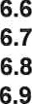
7
7.1
7.2
7.8
7.4
7.5
7.6
7.7
7.8
7.9
8.1
8.2
9
Selection of Storage Concept 5-11
Design and Performance Criteria 6-1
General 6-1
Spacing Requirements 6-1
Liquid Levels and Volumes 6-1
Performance Criteria 6-1
Design Loads and Load Combinations 6-7
Seismic Analysis 6-8
Foundation Design 6-10
Thermal Corner Protection System (TCP) for Concrete Tanks 6-11
Thermal Protection System (TPS) 6-11
Accessories and Appurtenances. 7-1
General 7-1
Access 7-1
Process Piping 7-1
Relief Valves 7-3
Instrumentation 7-5
Foundation Accessories 7-7
Fire, Gas, and Spill Protection 7-8
Electrical 7-8
Miscellaneous 7-9
Quality Assurance and Quality Control 8-1
Introduction 8-1
NDE, Testing, and Tolerances 8-1
Insulation 9-1

Page
  - System Design 9-1
  - General Requirements. 9-1
  - Load-bearing Insulation for Single, Double, and Full Containment Tank Systems 9-1
  - External Wall and Roof Insulation 9-2
  - Internal Wall Insulation for Single, Double, and Full Containment Tank Systems 9-3
  - Suapended Deck Insulation 9-4
  - Penetration and Internal Piping Insulation 9-4
  - Load-bearing Insulation for Membrane Containment Tank Systems 9-4
  - Nonmetallic Thermal Protection System. 9.5
  - Examination Methods of Nonmetallic TPS or TCP. 9.6
  - Specifications for Insulation. 9.7
- Tank Testing and Post-construction Activities. 10-1
  - Scope. 10-1
  - General 10-1
  - Hydrostatic and Pneumafic Testing 10-1
  - Drying and Purging 10-2
  - Cooldowri 10-3
- Marking 11-1
  - Nameplates 11-1
  - Certification 11-2
  - Report 11-2
Annex A (informative) Properties of Gases .......................................................A-1 Annex B (informative) Recommendations on Foundation Settlement ................................B-1
Annex C (informative) Commentary On Storage Concepts .........................................C-1 Annex D (informative) Recommendations on Selection of Storage Concept Based on Assessment of Risk D-1 Annex E (informative) Inquiries and Suggestions for Change .......................................E-1
Figures
- Example of Corrugations on the Membrane 3-2
- Single Containment Tank System
Single Wall with Steel Primary Liquid Container and Suspended Insulation Deck 5-2
- Single Containment Tank System
Single Wall with Steel Primary Liquid Container and External Insulation. 5-2
- Single Containment Tank System
Double-wall with Steel Primary Liquid Container and Steel Vapor Container 54
0 Single Containment Tank System
Double-wall with Steel Primary Liquid Container and Steel Purge Gas Container 5-3
- Double Containment Tank System
Steel Primary Liquid Container and Steel Secondary Liquid Container 5-4
- Double Containment Tank System
Steel Primary Liquid Container, Steel Vapor Container, and Concrete Secondary Liquid Container 5-4
- Full Containment Tank System
Steel Primary Liquid Container, Steel Secondary Liquid Container, and Steel Roof. 5-6
- Full Containment Tank System
Steel Primary Liquid Container, Concrete Secondary Liquid Container, and Steel Roof 5-6
- Full Containment Tank System
Steel Primary Liquid Container, Concrete Secondary Liquid Container, and Concrete Roof 5-7

Page
- Full Containment Tank System
Concrete Primary Liquid Container, Concrete Secondary Liquid Container, and Concrete Roof. .. . . .5-7
- Fulll Containment Tank System
Double-roof with Steel Primary Liquid Container and Concrete Secondary Liquid Container S-8
Membrane Containment Tank System
Type M-1: Membrane with Steel Membrane Tank Outer Container ...............................5-9
- Membrane Containment Tank System
Type M-CC: Membrane with Steel Membrane Tank Outer Container 5-10
- Membrane Containment Tank System
Type M-CC: Membrane and Concrete Membrane Tank Outer Container 5-11
16a Liquid Levels and Volumes (Tanks with Suspended Deck) 6-2
16b Liquid Levels and Volumes (Tanks with Refrigerated Temperature Roof} 6-2
17a General Information and Primary Liquid Container Nameplate. 11-3
17b Additional Container Nameplate 11•4
17c Membrane Containment Tank System Nameplate 11-5
18 Contractor's Certification for a Tank System Built to API Standard 625 11-6
Tables
- Status of Annexes to API Standard 625 1-1
- Summary of Applicable Seismic Events by Tank System and Component. 6-7
- Recommended Drying and Nitrogen Purging End Points 10-3
  - Physical Properties of Gases (SI Units) .................................................... A-2
  - Physical Properties of Gases (USC Units) .................................................. A-3

Tank Systems for Refrigerated Liquefied Gas Storage

SECTION 1—SCOPE

  - General

    - This standard covers low pressure, aboveground, vertical, and cylindrical tank systems storing liquefied gases requiring refrigeration. This standard provides general requirements on responsibilities, selection of storage concept, performance criteria, accessories/appurtenances, quality assurance, insulation, and commissioning of tank systems.

    - Additional information and recommendations are given in annexes. These general requirements address issues common to all of these tank systems, issues involving coordination of the components of the tank system, and issues of the tank system acting in an integrated way. The detailed requirements applicable to the metallic and concrete containers respectively are contained in the standards named in 1.4 and 1.5.

    - The annexes of this standard provide additional information that may be used in the selection and design of refrigerated tank systems. See Table 1 for the status of each annex.
Table 1—•Status of Annexes to API Standard 625

Annex | Title | Status
A | Properties of Gases | Information (informative)
B | Recommendations on Foundation Settlement | Recommendations (informative)
c | Commentary’ on Storage Conœpts | Information (informative)
D | Recommendations on Selection of Storage Concept based on Assessment of Risk | Recommendations (informative)
E | Inquiries and Suggestions for Change | Recommendations (informative)
  - Coverage

    - This standard covers tank systems having a storage capacity of 800 cubic meters (5000 bbls) and larger.

    - Stored product shall be liquids that are in a gaseous state at ambient temperature and pressure and that require refilgeration to less than 5 'C (40 °F) to maintain a liquid phase.

    - Tank systems with a minimum design temperature of —198 °C (-325 ”F) (see note), a maximum design internal pressure of 50 kPa (7 psig), and a maximum design uniform external pressure of 1.75 kPa (0.25 psig) are covered.

NOTE For concrete containers, ACI 376 states it “has been developed with the lowest operating temperature of —168 °C (—270 °F). However lower product temperatures could also be used, provided appropriate additional engineering analysis and justification is performed for each proposed application.”

  - Configuration

The tank system configurations covered are described in Section 5.

  - Metallic Components

Metallic components' materials, design, fabrication, inspection, examination, and testing shall be in accordance with API 620 including Annex Q, Annex R, or Annex Y. The applicable annex of API 620 depends on the design metal temperature and the applicable temperature ranges given in these annexes.

  - Concrete Components

Concrete component materials (including nonmetallic barriers), design, construction, inspection, examination, and testing shall be in accordance with ACI 376.

  - Boundaries

    - This standard applies to tank system components attached to and located within the liquid, vapor, and any purge gas containers (but excluding dike walls). Piping connected externally to the liquid, vapor, and any purge gas containers within the following limits shall be constructed according to this standard:

- the face of the first flange in bolted flanged connections;

- the first threaded joint on the pipe outside the tank wall in threaded pipe connections;

- the first circumferential joint in welding-end pipe connections that do not have a flange located near the tank.

    - The boundary of this standard may be extended as agreed between purchaser and tank system contractor to complete, external, pressure-containing piping connections (such as relief valves in 7.4 and instrumentation in 7.5) which serve only the tank system.

The following documents are ieféned to in the text in such a way that some or all of their content constlMes requirements of this document. For dated references, only the edition cited applies. For undated references, the latest edition of the referenced document (including any addenda) applies.
API Standard 521, Pressure-ieliaving and Depiessurizing Systems
API Standard 537, Flaie Details for General Refinery and Petrochemical Service Construction Guidelines
API Standard 620, Design and Construction of Large, Welded, Low-Pressure Storage Tenks

API Standard a50, API Welded Tanks for Oil Storego

API 2000, Venting Atmospheric and Low-pressure fitorape Tenks
API Specifiœtion Qt, Specification for Quality Programs

ACI 376 1, Cade Requirements for Design end Construction of Concrete Structures far the Containment of Refrigerated Liquefied Geses and Commentary
AGA XK 0101 2, Purging Pifinciples and Practice

ANSI K61.1 ^, American National Standard Safely Requirements fiar tfie Storage and Handling of Anhydious Ammonia
ASCE 7 *, Minimum Design Loads for Buildings and Otfier Structures

ASME B31.3 +, Process Piping

ASME Boiler and Pressure Vessel Code, Section VIII: Rules far Construction of Preasuie Vessels Division 1
ASTM A516 , Standard Specification far Pressure Vessel P/ales, Carbon Steel, iâr Moderate- and Lower- Temperature Serv/ce

ASTM A553, Standard Specification far Pressure Vessel Plates, Alloy Sfieel, Quenched and Tempered 8 and 9 Pement Nickel
ASTM C165, Standard Test Metfiod tor Measuifing Compressive Properties of Thermal Insulations

ASTM C177, Standard Test Method for fiteady-state Heat Flux Measurements and Chennai Transmission Properties by Means of the Guarded-Hot-Plate Apparatus
ASTM C240, Standard Test Methods of Testing cellular G/ass Insulation Block
ASTM C552, Standard Specification /'or Cellular Glass Insulation

ASTM C549, Standard Specification for Perlite Loose Fill Insulation

' American Concrete Institute, P.O. Box 8094, Farrnington HiIla, Michigan 48333, aci-int.org.
2 AmericanGas Association, 400 N. Capitol St., NW, Suite 450, Washington, D.C. 20001, www.aga.org.
* American National Standards Institute, 25 West 43 Street, 4” Floor, New York, New York 10036, ansi.org.
^ American Society of Civil Engineers, 1801 Alexander Bell Dr., Reston, Virginia 20191, www.asoe.org. ’ ASME International, 3 Park Avenue, New York. New York 100164990, asme.org.
^ ASTM International, 100 Barr Harbor Drive, West Conshohocken, Pennsylvania 19428, www.astm.org.

ASTM C764, Standard Specification for Mineral Fiber Loose-Fi// Tfiennal Insulation

EN14620-1 ’, Design and manufactum of site built, vertical, cylindrical, flat-bottomed sfee/ tanks far the storage of
reffigerated, liguefied gases w”ith operating temperatures beMeen 0 °C and-165 °C — Pan 1: General
EN 14620-4, Design and manufacture of site built, vertical, cylindrical, flat-bottomed steel tanks for the storage of

refrigerated, liquefied gasses with operatingtemperatures beMeen 0 ’G and -165 ’G — F'art 4: Insulation
IBC ^, ICC lntemafional Building Code

ISO 9001 , Quality Management Requirements NFPA 58 1^, Liquefied Petroleum Gas Code NFPA 59, Utility LP- Gar Plant Code
NFPA 59A, Standard for the Pioducfion, Storage, and Handling of Liquefied Natural Gas (LNG)

NFPA 255, Standarcl Method of Test of Surface Burning Characteristics of Building Materials

NFPA 497, Classification of Flammable Liquids, Gases, or Vapors and at Hazardous (Classified) Locations for Electrical Installations in Chemical Process Areas
NFPA 780, Standard far the Installation of Lightning Protection Systems
OSHA 29 CFR 1910 11, Subpart D, Walking-Working Surfaces

Euiopean Committee for Standardization, Avenue Marnix 17, B-1000, Brussels, Belgium, www.cen.eu.
^ International Code Council, 500 New Jersey Avenue, NW, 6th Floor, Washington, D.C. 20001, www.iccsafe.org.
^ International Organization for Standardization, 1, ch. de la Voie-Cause, Case postale 56, CH-1211, Geneva 20, Switzeñand,
10 National Fire Protection Association, 1 Batterymaich Park, Quincy, MassachuseM 02169•7471, nfga.org.
t1 U.S. Department of Labor Occupational Safety and Health Administration, 200 Consfitution Avenue, NW, Washington, DC
20210, www.osha.gov.

  - General

For the purposes of this document, the following definitions apply.

  - Definitions

    - Storage Concept

3.2.1.1
double containment tank system See 5.3.
3.2.1.2
double conBinmentwith-penetrations tank system
See 5.5.

full containment tank system See 5.4.
3.2.1.4
full containment•wlth-penetrations tank aystem See 5.5.
3.2.1.5
membrane containment tank system
See 5.6

3.2.1.6
membrane containment Type M-CC with penetrations Bnk system See 5.7

3.2.t7
single containment tank system
See 5.2

3.2.1.8
tank system
Equipment designed for the purpose of storing refrigerated liquified gas consisting of one or more container, together with all other necessary oomponents within the scope of this standard.

    - Component
3.2.2.1
annular space
The space between a) the primary cylindrical liquid container and the primary cylindrical product vapor container or b) the primary cylindrical liquid oontainer and the cylindrical purge gas container of a double-wall tank.

3-1

12 API STANDARD 625

3.2.2.2

baae heating system
A heating system provided in the base slab or soil below the tank system to prevent freezing of the soil and frost heave.
3.2.2.3
base slab
A continuous concrete base supporting the tank system. This base may exist either at grade or elevated and may be either supported by soil or piles.
3.2.2.4
corrugation
Patterned ridges on the membrane designed to allow for shrinkage and movement under all loadings of the membrane (see Figure 1).
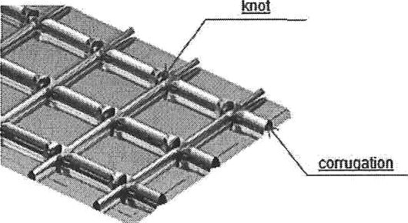

Figure 1—Example of Corrugations on the Membrane
3.2.2.5
dike wall
A structure remote from the tank system used to establish an impounding area for the purpose of containing any accidental spill of stored liquid. Sometimes this structure is referred to as a bund wall.
3.2.2.6
elevated foundation
A foundation with base slab, supported either by piles or piem (stub columns), located at an elevation above grade, leaving an air gap between the grade and the bottom of the base slab.
3.2.2.7

The intersection of the membrane corrugations that provides two-directional flexibility (see Figure 1).
3.2.2.8
load-bearing insulation
Insulation with special compressive strength properties used for thermal insulation and for transferring the load to the load-bearing structure.
3.2.2.9
membrane
Parts of a membrane containment tank system that form a liquid- and vapor-tight barrier during normal operation (see Figure 1).

3.2.2.10
membrane tank outer container
The parts in a membrane containment tank system that carry liquid load during normal operation and may contain liquid in the event of liquid leakage from the membrane.
3.2.2.11
moisture barrier
A barrier to prevent entry of water vapor and other atmospheric gases.

3.2.2.12
OBE baeis operating level
The design liquid level used for operating basis earthquake (OBE) design.

3.2.2.13
penetratlon
A permanent opening, other than a manway, that is placed in a liquid. vapor. or purge gas container.

3.2.2.14
primary liquid container
Parts of a single, double, and full containment tank system that contain liquid during normal operation.

3.2.2.15
primary vapor container
Parts of a tank system that contain the product vapor during normal operation.

3.2.2.16
pump column
A pipe column to house a combined vertical pump and dose-coupled electric motor. The column itself protrudes through the outer tank roof.
3.2.2.17
purge gas container
Parts of a tank system that contain only purge gas and are not expected to function after exposure to product temperature. (This includes outer conlainer of double-roof single containment tank system.)
3.2. 18
refrigerated temperature roof
A structural roof that contains product vapor and is near the liquid product temperature during normal operation. (This includes inner roofs of double-roof tanks and single roofs of tanks with external roof insulation.)
3.2.2.19
ring beam
A circular load-bearing component under the shell of the primary liquid container.

3.2.2.20
roof space
The space between the refrigerated temperature roof and the purge gas container roof.

3.2.2.21
secondary liquid conBiner
Parts of a double and full containment tank system that contain the liquid in the event of leakage from the primary liquid container.

    - J2
suspended deck
Structure suspended from the inned roof, used for supporting the internal insulation above the primary liquid container.

3.2.2.23
thermal corner prolactlon
A liquid-tight protection system loated at the base of a membrane tank container or secondary liquid container, used to moderate thermal gradients at that location.

3.2.2.24
thermal protection system
A thermally insulating and liquid-tight system to protect the membrane tank outer container or the secondary liquid container against low temperatures in the event of leakage through the membrane or primary liquid container, respectively. The thermal protection system in the bottom annular section is functionally equivalent to the thermal comer protection system.

3.2.2.25
warm product vapor container
Parts of a tank system that contain product vapor and prevent entry of water vapor and other atmospheric gases during normal operation but that are not expected to function after exposure to refrigerated product temperature. (This indudes roofs over suspended insulation deck and the outer container of a double-wall, open top single containment tank system.)

3.2.2.26
membrane attachment anchors
Attachment device to provide a rigid point support of the insulation to the membrane tank outer container (see

    - Levela and Volumes 3.2.3.1
design liquid level
Maximum liquid level that will be experienced during operation of the tank.

3.2.3.2
maximum liquid capacity
The total volume between the design liquid level and the tank bottom. (This is also referred to as total liquid capacity in API 620.)

3.2.3.3
maximum normal operating capacity
The volume between the maximum normal operating level and the tank bottom.

3.2.3.4
maximum normal operating level
Maximum liquid level that will be experienced during normal operation of the tank.

3.2.3.5
minimum normal operating level
Minimum liquid level that will be maintained during normal operation of the tank.

3.2.3.6
net working capacity
The volume between the maximum normal operating level and minimum normal operating level.
3.2.3.7
overkill prevention margin
Capacity (tank height or volume) between the maximum normal operating level and the design liquid level (see 6.3).

freeboard
The height above the maximum design liquid level required to accommodate operational and upset conditions.
3.2.3.9
seismic freeboard
The height above the operating liquid level required to accommodate seismic-induced sloshing waves.
3.2.3.10
heel
The height of liquid below the minimum normal operating level.

3.2.4.1
The process of vaporization of refrigerated product by heat conducted through the insulation surrounding the tank.
3.2.42
design pressure
The maximum gauge pressure permissible in the vapor space above the product of a tank system in its design condition.
3.2.4.3
flame apread index
A number, obtained aocording to NFPA 255, which is a comparative measure, derived from visual measurements, of the spread of flame vs time.
3.2.44
An event having the potential to cause harm, induding ill health and injury; damage to property, product or the environment; production losses; or increased liabilities.
3.2.4.5
minimum design temperature (dmign metal temperature) See 6.4.6.
3.2.4.6
purging
The replacement of one gas/vapor by another in an enclosed tank system by displacement, by dilution, by diffusion or by combinations of these actions.

3.2.AI
Uncontrolled mass movement of stored liquid, correcting an unstable state of stratified liquids of different densities and resulting in a significant evolution of product vapor.

3.2.4.8
set pressure
The gauge pressure at which the pressure relief device first opens.
3.2.4.9
set vacuum
The gauge pressure at which the vacuum relief device fimt opens.
3.2.4.10
lowest one-day mean ambient temperature
Meteorological data for the specific site.

NOTE This information for U.S. locations is presented in API 620, as well as other options for locations not covered in that standard.
    - Seismic
3.2.5.1
aftershock level earthquake

ALE
See 6.5.2.
3.2.5.2
operating basis earthquake OBE
operating level earthquake OLE
See 6.5.2.
3.2.5.3
eafe shutdown earthquake SSE
contingency level earthquake CLE
See 6.5.2.

seismic sloshing wave height
Height of wave in the stored liquid due to seismic ground movement.

    - Organizations
3.2.6.1
purchaser
The owner of the tank system or the owner's designated agent.
3.2.6.2
tank system contractor
The party having the responsibility for design, supply, fabrication, construction, examination, and testing the tank system unless otherwise agreed per 4.1.2.

41.1 The ownerlpurchaser shall provide the specification defining the tank design from design information specified below.
    - The tank system contractor shall be responsible for the design, supply, fabriation, construction, examination, and testing of the tank system in accordance with the design information named in 4.2 unless otherwise agreed to by the purchaser and the tank system contractor.
    - The supply of the tank system requires input from multiple specialist subcontractors and vendors. The tank system oontractor shall ensure that division and delegation of responsibilities are defined and the tank system is fully integrated.

  - Design Information
    - Information by Purchaser
The purchaser shall provide the following information:
      - scope of work for contractor (including items determined in 4.2.3);
      - tank type (see Section 5);
      - net woñdng capacity;
      - tank location on plot plan;
      - environmental data (including, minimum/maximum ambient temperatures);
      - site geotechnical and seismic data (including soil propertia, allowable soil bearing, predicted settlements after soil remediation, and foundation type selected); when a site-specific seismic response spectrum is required per Section L.4.2 in API 620, as a minimum, the site-specific spectrum should be based on the requirements in
6.6.2 in this document;
      - process flow diagrams (PFDs), piping & instrumentation diagrams (P&lDs);
      - properties of the stored product. induding density at the design temperature, toxicity, and flammability;
      - design pressure/vacuum, maximum/minimum operating pressure;
      - higMow pressure alarm set point;
      - design boil-off rate (as per 6.4.4);
      - minimum design temperature of primary liquid, secondary liquid, warm product vapor, purge gas, and membrane tank outer containers and the membrane (in accordance with 6.4.6);
      - natural environmental loads (such as earthquake, wind);
      - type of cathodic protection system (if applicable);
      - product filling/emptying rates;

+1

      - spillage handling requirements (as per 6.4.2 and 7.7, if applicable);
      - rollover appliability and rollover prevention provisions (as per 7.5.4, if applicable);

      - piping and instrumentation requirements (as per 7.3 and 7.5);

      - corrosion allowanoes;
      - hazard protection system requirements (such as water spray, gas detection. if any);
      - accidental loads determined by assessment of risk (such as fire. pressure wave, projectile impact, if any);

      - overkill prevention margin (refer to 6.3);

      - minimum normal operating level basis;

      - number of loading and unloading cycles during the lifetime;
    - Information by Tank System Contractor

The contractor shall provide the following information:

      - tank maximum liquid capacity;

      - internal dimensions (diameter and height) of primary liquid container or membrane at ambient temperature;

      - design liquid levet;

      - normal maximum/minimum operating liquid level;

      - high/low level alarm.

  - Agreement by Tank Purchaser and Tank System Contactor

The following issues shall be agreed by both parties:
    - applicable codes and standards;
    - contractor's involvement in risk assessment;
    - materials of tank construction;
    - precommissioning and commissioning procedures, including purging, drying, and cooldown;

    - NDE applied to nonhydrostatially tested components;
    - seklement prediction and inspection method;
    - emergency relief valve discharge flow rate;

    - pressure relief and vacuum set points.

    - Several different main storage concepts are addressed in this standard. 5.2, 5.3, 5,4, 5.5, 5.6, and 5.7 define and describe each of these concepts. Diagrams of some implementations of these concepts are also provided. These diagrams are not meant to exclude other variations as long as they conform to the concept definitions.

    - Other storage concepts falling outside those defined herein may be possible but are not addressed in this standard.

    - In the diagrams provided, color is used to help illustrate the components that are designed for the low product temperatures (blue metal or gray concrete) and other components that are not so designed (red metal).

    - For all storage concepts, liquid-tightness of the primary liquid container or the membrane is required. Liquid is not permitted to accumulate outside the primary liquid container or the membrane during normal operation. Tank systems where this is not assured would require consideration of issues such as liquid collection and disposal, potential cold spots, effect on tank venting, etc. This standard has not attempted to address these issues.

  - Single Containment Tank System

    - This system incorporates a liquid-tight container and a vapor-tight container. It can be a liquid- and vapor-tight single-wall tank or a tank system composed of an inner and outer container, designed and constructed so that only the primary liquid container is required to be liquid-tight and contain the liquid product.

    - The outer container, if any, is primarily for the retention and protection of the insulation system from moisture (see Section 9) and may hold the product vapor pressure, but is not designed to contain the refrigerated liquid in the event of leakage from the primary liquid container.

    - The primary liquid container shall be of low-temperature metal or prestressed concrete. The outer tank (if any) shall be vapor-tight. It is normally made from carbon steel, and it is referenced in this standard in various contexts as the warm product vapor container or the purge gas container.

    - A single containment tank system is surrounded by a secondary containment (normally a dike wall) which is designed to retain liquid in the event of leakage (see C.2).

    - Some vañants of single containment concepts having a single tank are depicted in Figure 2 and Figure 3.

    - Some variants of single containment concepts having inner and outer containers are depicted in Figure 4 and Figure 5.

    - Shell or bottom penetrations that breach the primary liquid container and outer container are allowed.

5-1

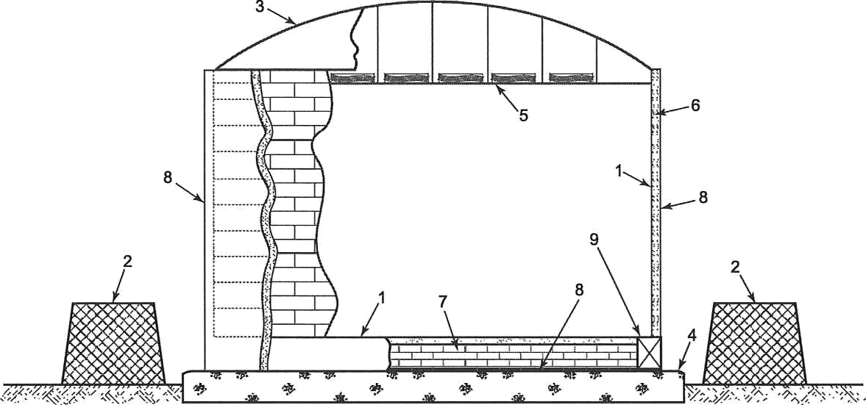

Key
      - primary liquid container (low temp steel) 5
      - secondary containment(dike wall) 6
      - warm product vapor container (roof} 7
      - concrete foundation 8
suspended deck with insulation insulation (external)
load-bearing insulation (bottom) moisture barrier
9 ring beam

Figure 2—Single Containment Tank System
Single Wall with Steel Primary Liquid Container and Suspended Insulation Deck

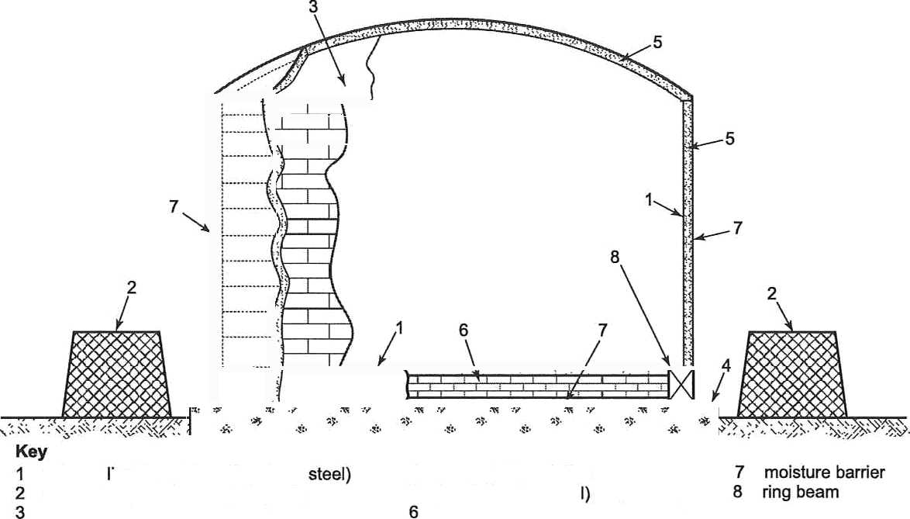
primary iquid container (low temp secondary containment (dike wall) refrigerated temperature roof

- concrete foundation
- insulation (extema
load-bearing insulation (bottom)

Figure 3—Single Containment Tank System
Single Wall with Steel Primary Liquid Container and External Insulation

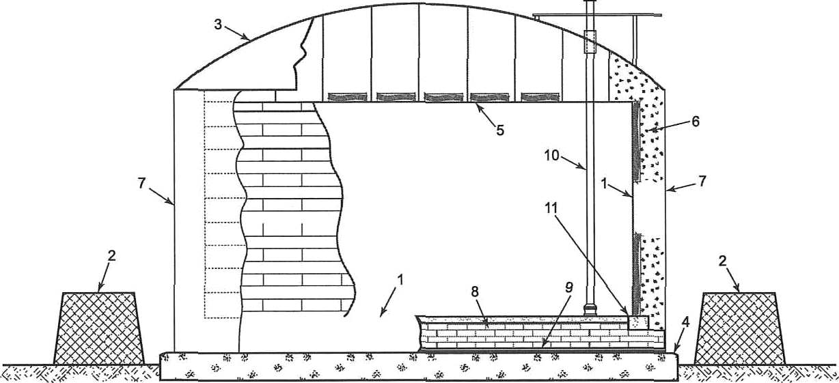

primary liquid container (low temp steel) 5
2 secondary containment (dike wall) 6
warm product vapor container (room 7
concrete foundation
suspended deck with insulation 8 load-bearing insulation (bottom) insulation (annular) 8 warm product vapor container (bottom) warm product vapor container 10 pump column
(wall) 11 ring beam

Figure Single Containment Tank System
Double-wall with Steel Primary Liquid Container and Steel Vapor Container

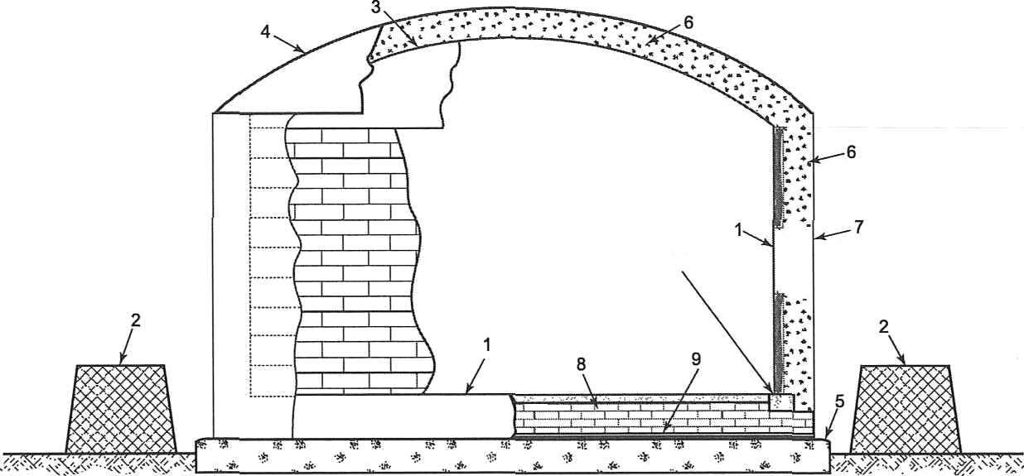
Key
10

primary liquid container (low temp steel) 4

purge gas container (roof} 7 purge gas container (wall)

- secondary containment (dike wall) 5
- refrigerated temperature roof 6
concrete foundation 8 load-bearing insulation (bottom) insulation (annular and roof space) 9 purge gas container (bottom)
10 ring beam

Figure 5—Single Containment Tank System
Double-wall with Steel Primary Liquid Container and Steel Purge Gas Container

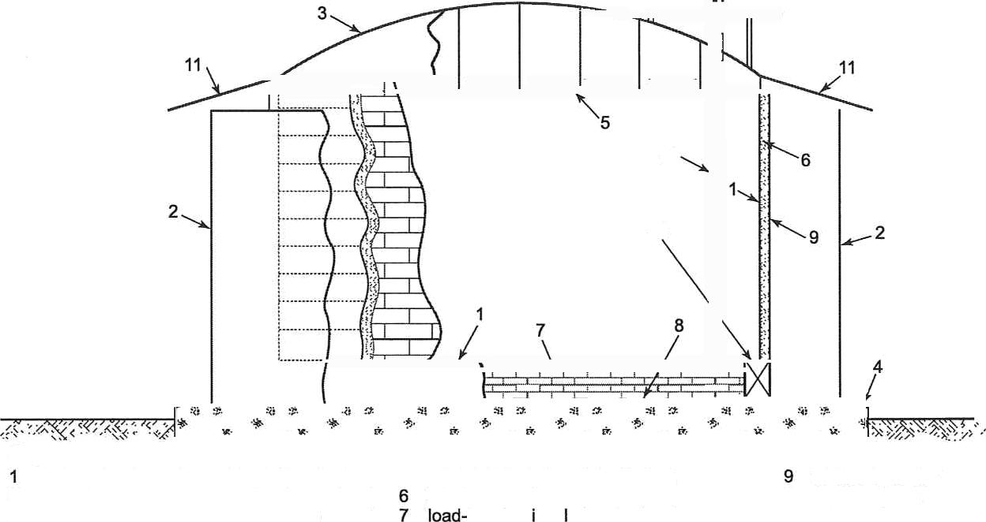
10

12

Key
primary liquid container (low temp steel) 5 suspended deck with insulation moisture barrier
- secondary liquid container (low temp stee!) insulation (external) 10 pump column
- warm product vapor container (room bearing nsu ation (bottom) 11 rain shield
- concrete foundation 8 secondary liquid container (low temp steel) 12 ring beam
Figure 6—Double Containment Tank System
Steel Primary Liquid Container and Steel Secondary Liquid Container
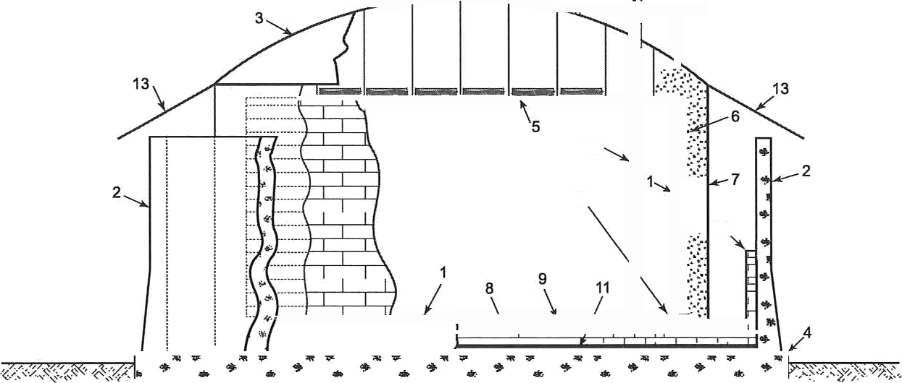
12

14
10
Key
- primary liquid container (low temp steel) 6 insulation (annular space) 10 thermal comer protection
- secondary liquid container (concrete) 7 warm product vapor container (wall) 11 moisture barrier
- warm product vapor container (roof) B |oad-bearing insulation (bottom) 12 pump column
- concrete foundation 9 secondary liquid container (jow temp steel) 13 rain shield
- suspended deck with insulation 14 ring beam
Figure 7—Double Containment Tank System
Steel Primary Liquid Container, Steel Vapor Container, and Concrete Secondary Liquid Container

  - Double Containment Tank System

    - This consists of a liquid- and vapor-tight primary tank system, which is itself a single containment tank system, built inside a liquid-tight secondary liquid container.

    - The secondary liquid container is designed to hold all the liquid contents of the primary liquid container in the event of leaks from the primary liquid container, but it is not intended to contain or control any vapor resulting from product leakage from the primary liquid container. The annular space between the primary liquid container and the secondary liquid container shall not be more than 6 m (20 ft).

    - The primary and secondary liquid containers shall be constructed either from metal or from concrete.

    - Variants of double containment concepts using single tanks and independent primary liquid and vapor containers are depicted in Figure 6 and Figure 7.

    - Shell or bottom penetrations that breach the primary or secondary liquid container are not allowed.

  - Full Containment Tank System

    - This consists of a liquid-tight primary liquid container and a liquid- and vapor-tight secondary liquid container. Both are capable of independently containing the product stored.

    - The secondary liquid container shall be capable of both containing the liquid product and controlling the vapor release in the event of product leakage from the primary liquid container.

    - The primary and secondary liquid containers shall be constructed either from metal or from concrete.

    - Vapor tightness of the tank system during normal service is required. Under primary liquid container leakage (emergency) conditions, tank system product vapor losses due to secondary container permeability are acceptable.

    - ACI 376 addresses various base-to-wall joint details. For certain low-temperature products, significant design issues arise at monolithically-connected outer tank base-to-wall joints due to the mechanical restraint offered by the base. To mitigate these issues, it is normal practice to include a secondary liquid containment bottom and thermal corner protection to protect and thermally isolate this monolithic area from the cold liquid and provide liquid tightness. Refer to ACI 376 for the design and detailing of such areas. The diagrams in this section approximately depict such details. Details of this subject are in 6.8 of API 625.

    - Some variants of full containment concepts are depicted in Figure 8, Figure 9, Figure 10, Figure 11, and Figure 12.

    - Shell or bottom penetrations that breach the primary or secondary liquid container are not allowed.

    - In case of tanks with refrigerated temperature roof, the primary liquid container and refrigerated temperature roof shall both be capable of containing liquid and vapor product during normal service.

  - Double or Full Containment-with-Penetrations Tank System

This concept meets the requirements of double or full containment tank systems defined in 5.3 and 5.4, respectively, except shell or bottom penetrations and manways that breach the primary or secondary containment are allowed when all of the following additional requirements are met.

- the penetrations are specified by the purchaser;

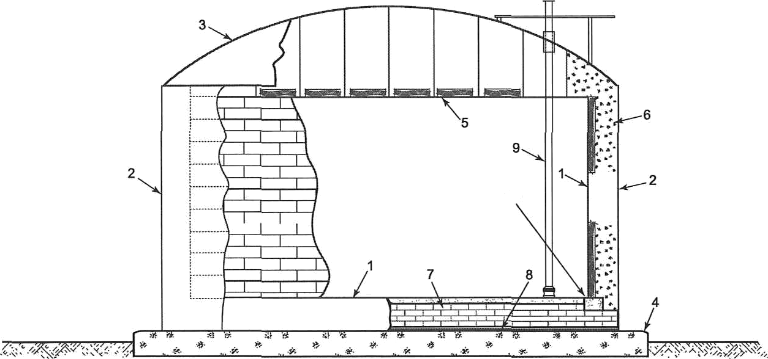
10

- primary liquid container (low temp steel) 5
- secondary liquid container (low temp steel) 6
- warm product vapor container (roof) 7
- concrete foundation
suspended deck with insulation 8 secondary liquid container insulation (annular space) (low temp steel)
load-bearing insulation (bottom) 9 pump column
10 ring beam

Figure WFuII Containment Tank System
Steel Primary Liquid Container, Steel Secondary Liquid Container, and Steel Roof

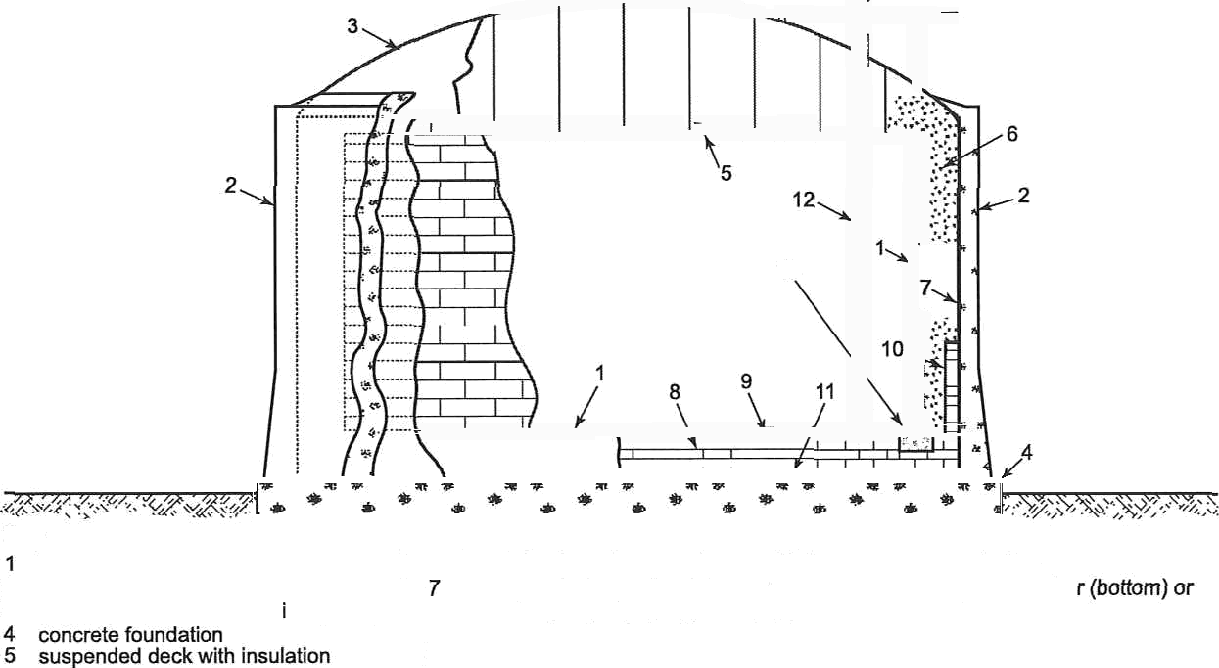
13

Key
primary liquid container (low temp steel) 6
- secondary liquid container (concrete)
- warm product vapor conta ner (roof}

insulation (annu|ar space) 10 thermal corner protection warm product vapor container 11 warm product vapor containe (liner) moisture barrier
load-bearing insulation (boftom) 12 pump column therma| protection system 13 ring beam

Figure WFuII Containment Tank System
Steel Primary Liquid Container, Concrete Secondary Liquid Container, and Steel Roof

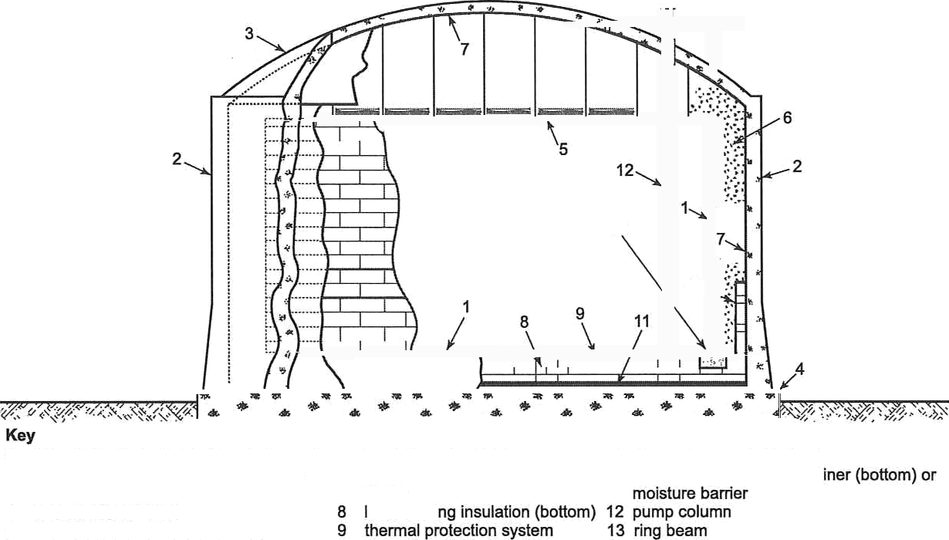
13
- primary liquid container (low temp steel) 6 insulation (annular space) 10 thermal comer protection
- secondary liquid container (concrete) 7 warm product vapor container 11 warn product vapor conta
- roof (concrete) (liner)
- concrete foundation oad-beari suspended deck with insulation

10

Figure 10—Full Containment Tank System
Steel Primary Liquid Container, Concrete Secondary Liquid Container, and Concrete Roof

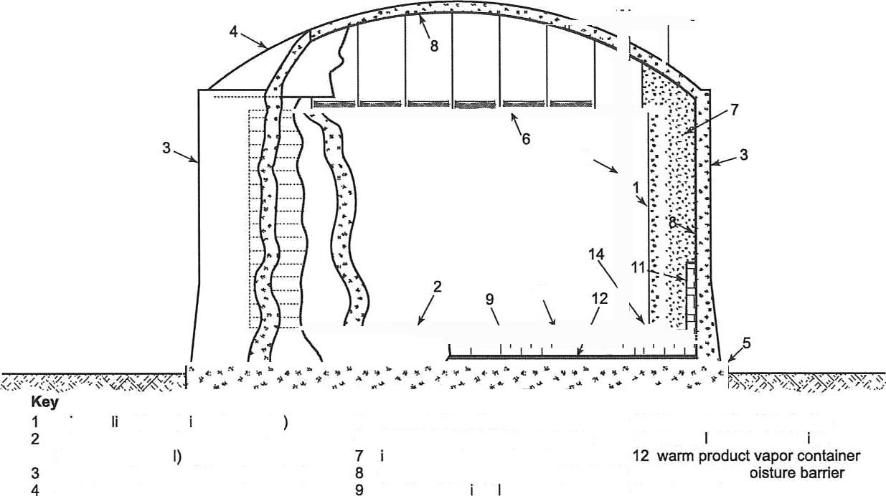
13

10

primary quid conta ner (concrete primary liquid container bottom (concrete or stee
secondary liquid container (concrete)
roof (concrete)
- concrete foundation 10 thermal protection system
- suspended deck with insulation 11 therma comer protect on nsulation (annular space)
warm product vapor container (liner) (bottom) or m load-bearing nsu ation (bottom) 13 pump column
14 ring beam

Figure 11—Full Containment Tank System
Concrete Primary Liquid Container, Concrete Secondary Liquid Container, and Concrete Roof

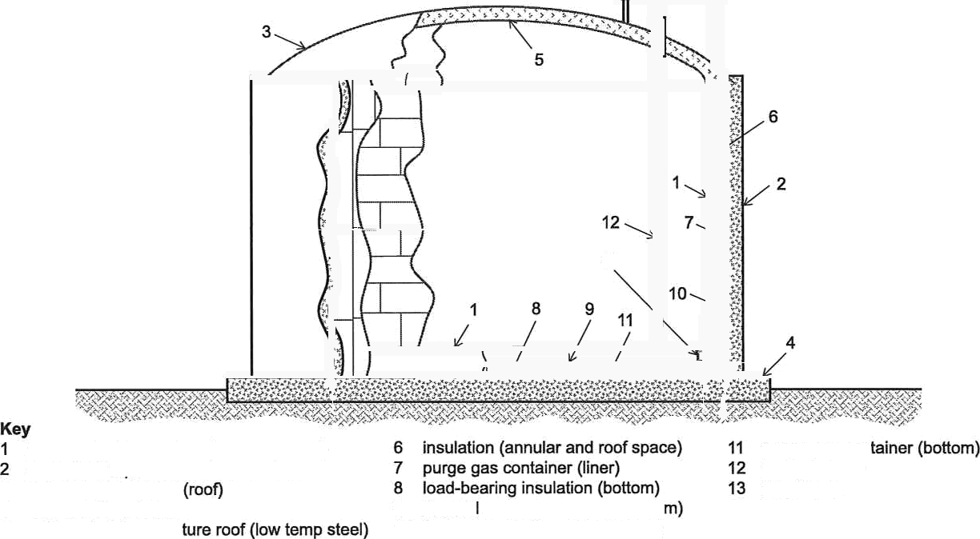
13
primary liquid container (low temp steal) secondary liquid container (concrete)
- purge gas container
- concrete foundation
- refrigerated tempera
purge gas con pump column ring beam
- therma protection system (botto
- thermal protection system (wall)
Figure 12—Full Containment Tank System
Double-roof with Steel Primary Liquid Container and Concrete Secondary Liquid Container

- no prohibition exists in applicable regulations;

- the penetrations are accounted for in the assessment of risk as per 5.8;

- in-tank valves are provided (refer to 7.3.1.4.2 b) for all penetrations except the following:

- dead end lines (such as drain lines) in secondary liquid container that do not exceed 4-inch NPS, nor exceed 18-inch projection;
- instrumentation cable glands through the secondary liquid container;

- a remote dike wall is provided in addition to the secondary containment that is part of the tank system. The volume contained by the dike shall be equal to 110 % of the flow from a full line break prior to closure of the largest in-tank valve.
S.6 Membrane Containment Tank System

    - This is an integrated tank system consisting of the metallic membrane, load-bearing thermal insulation, and self-standing membrane tank outer container.
    - The membrane shall be liquid tight and vapor-tight during normal operation.
    - The tank system shall be vapor-tight during normal operation. The tank system may use a suspended deck with insulation with vapor contained by the structural roof. Alternately, the tank roof may have a vapor-tight membrane and insulation lining as in 5.6.1

    - The membrane shall incorporate either a design with corrugations to accommodate thermal contraction or materials with acceptably small thermal contraction.
    - The load-bearing insulation transfers all hydrostatic loads and other loadings onto the membrane tank outer container.
    - The membrane tank outer container provides structural function for all normal and applicable abnormal design conditions.
    - The membrane tank outer container shall be self-standing and may be of metal, concrete, or metal/concrete combination.
    - If the membrane outer tank container is not moisture tight, a moisture barrier preventing entry of water vapor and other atmospheric gases shall be required to keep the insulation layer between the membrane and the outer tank dry.

    - The membrane containment tank system may be one of the two possible types. The purchaser shall select the type of the membrane tank outer container in accordance with 5.8,

      - Type M-1: The membrane tank outer container for this type is not designed to contain the product in the event of a leak from the membrane and no thermal protection system is provided. This tank system is surrounded by a secondary containment, normally a dike wall, which is designed to retain liquid in the event of leakage. Under normal conditions, the membrane tank outer container also acts as a purge gas container. One variation of this type is depicted in Figure 13. Shell or bottom penetrations that breach the membrane or membrane tank outer container are allowed.
      - Type M-CC: The membrane tank outer container for this type is designed to contain the product in the event of a leak from the membrane. The membrane tank outer container shall be capable of both containing the liquid product and controlling the vapor release in the event of leakage from the membrane. Under membrane leakage (emergency) conditions, tank system vapor product losses due to container permeability are acceptable. Under
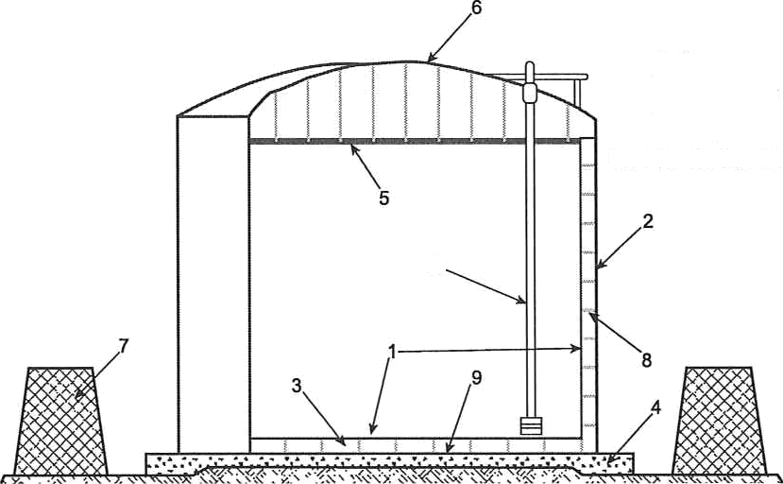

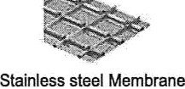
10

Key
        - membrane
        - membrane tank ouler container (wall)
        - load-bearing insulation (bottom)
        - concrete foundation

        - suspended deck with insulation 9 membrane tank outer container (bottom)
        - warm product vapor container (roof) 10 pump column
        - secondary containmenl (dike wall)
        - load-bearing insulation (wall)

Figure 13—Membrane Containment Tank System
Type M-1: Membrane with Steel Membrane Tank Outer Container

normal conditions, the metallic membrane tank outer container also acts as a purge gas container. Some variants of
this type are depicted in Figure 14 and Figure 15. Shell or bottom penetrations that breach the membrane or membrane tank outer container are not allowed.

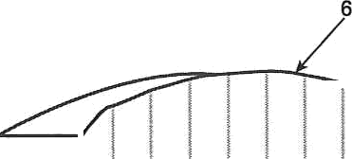
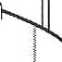
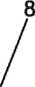
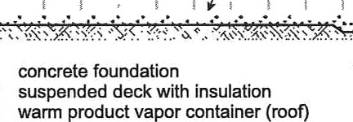

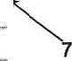
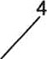
5
2

1

Key
- membrane 4
- membrane tank outer container 5
(low temp steel) 6
- load-bearing insulation (bottom)

- load bearing insulation (wall)
- membrane tank outer container (bottom, low temp steel)
- pump column

Figure 1WMembrane Containment Tank System
Type M-CC: Membrane with Steel Membrane Tank Outer Container

    - In case of concrete membrane tank outer container, ACI 376 addresses various base-to-wall joint details. For certain low-temperature products, significant design issues arise at monolithically connected outer tank base-to-wall joints due to the mechanical restraint offered by the base. To mitigate these issues, it is normal practice to include a thermal protection system and thermal comer protection to protect and thermally isolate this monolithic area from the cold liquid and provide liquid tightness. Refer to ACI 376 for the design and detailing of such areas. The diagrams in this section approximately depict such details. Details of this subject are in 6.8 of API 625.
  - Membrane Containment Type M-CC with Penetrations Tank System
This concept meets the requirements of membrane containment tank systems defined in 5.6, except shell or bottom penetrations that breach the membrane and membrane tank outer container are allowed when all of the following additional requirements are met.
- The penetrations are specified by the purchaser;
- No prohibition exists in applicable regulations.
- The penetrations are accounted for in the assessment of risk as per 5.8.
- In-tank valves are provided (refer to 7.3.1.4.2 b).

Key
1 membrane | 5 suspended deck with insulation | 9 thermal protection system
membrane tank outer container (concrete) | warm product vapor container (liner) | 10 thermal comer protection
load-beañng insulation (bottom) | 7 load-bearing insulation (wall) | 11 pump co umn
4 concrete foundation | roof (concrete) | 12 moisture barrier

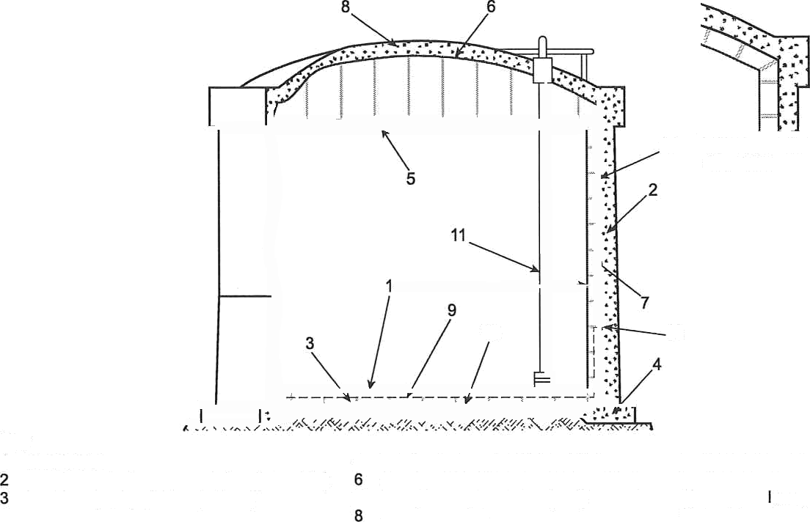
Figure 15—Membrane Containment Tank System
12 Variation of the roof See 5.6.3
12
10
Type M-CC: Membrane with Concrete Membrane Tank Outer Container

- A remote dike wall is provided in addition to the membrane tank outer container that is part of the tank system. The volume contained by the dike shall be equal to 110 % of the flow thorn a full line break prior to closure of the in-tank vaNe.
  - Selection of Storage Concept
The purchaser shall conduct a risk assessment of the tank system (see Annexes C and D). The purchaser shall consider risk in the selection of the storage concept.

SECTION 6—DESIGN AND PERFORMANCE CRITERIA

  - General

This section provides requirements for design of refrigerated tank systems to meet the performance criteria prescribed in 6.4 when subjected to applicable normal and abnormal design loads defined in 6.5. Requirements for performing the seismic analysis are presented in 6.6.

  - Spacing Requirements

Spacing of refrigerated gas storage tank systems from adjacent property and adjacent tanks shall be sufficient to support the requirements of 6.4.2. Refer to Annex D for additional guidance regarding tank spacing.

  - Liquid Levels and Volumes

Liquid levels and volumes used in this standard for design of the tank system are defined in Section 3 and as further noted below.

    - Figure 16, a multipart figure (Figure 16a and 16b) provides a graphical representation of the relationship of the terms used to define liquid levels and volumes.

    - The shell height of the primary liquid container shall be determined by the requirement herein.

      - For tanks with a suspended deck, a nominal freeboard of 300 mm (12 in.) above the design liquid level shall be included in the height of the tank as a buffer against overtopping and to provide for free vapor flow above the design liquid level. This shall be the lesser of the height of primary liquid container or top of the membrane above the maximum design liquid level and the distance between the maximum design liquid level and the suspended deck. The height of the tank may need to be increased further to satisfy seismic freeboard requirements. Seismic freebord shall be calculated per 6.6.8.

      - For tanks with a refrigerated temperature roof, consideration of a percentage of volume for vapor, design for cryogenic conditions if exposed, and dynamic behavior of the fluid under a seismic event shall be considered in the design. The design liquid level shall not be higher than the top of the shell.

    - The overfill prevention margin shall be determined by the purchaser in terms of tank height, volume, or trip times beMeen the maximum normal operating level and the design liquid level to accommodate process shutdown prior to reaching the design liquid level.

    - The minimum normal operating level shall be determined and specified by the purchaser. This level may be determined as the minimum level for pump restart, or may be the minimum pump down level, including reduced pumping rates. The minimum norrrial operating level shall be set at no less than 150 mm (6 in.) in order to maintain the operating temperature of the tank.

  - Performance Criteria

    - Normal Operation

      - The primary liquid container or the membrane with membrane tank outer container shall contain the liquid under all normal operating loads and conditions. Refer to Section 5 for further definition of the meaning of normal operation liquid containment for various storage concepts.

      - The primary vapor container shall be vapor-tight during normal operation.

6-1


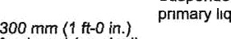
suspended deck or top of
uid container
fj eeboard (nominal)
Design liquid level
O E

OBE basis
operating level
Maximum normal operat ng level
E
operating level
Seismic freeboard SSE

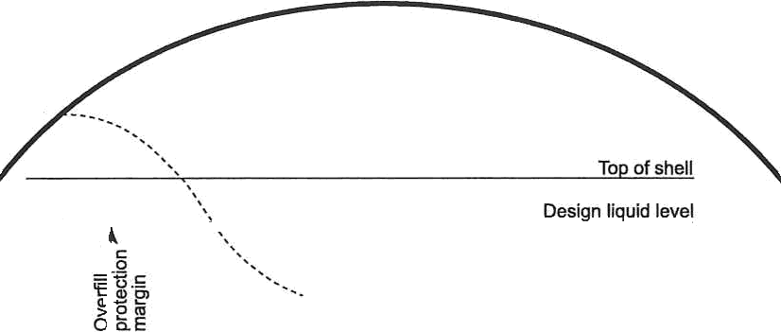
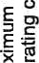
Figure 16a—Liquid Levels and Volumes (Tanks with Suspended Deck)
a‘
w
Maximum normal operating level
E o o
E
Minimum normal
operating level
Seismic
OBE or
Heel

Figure 16 Liquid Levels and Volumes (Tanks with Refrigerated Temperature Roof}
Net working capacity
Heel

      - The primary vapor containef shall have adequate structural capacity to allow for vent overpressure.

    - Abnormal and Emergency Conditions

      - Liquid Containment and Emergency Conditions

- The primary liquid container or the membrane with membrane tank outer container shall be designed to maintain liquid containment under the abnormal and emergency conditions specified herein and in the risk assessment.

- However, if the liquid-tightness of the primary liquid container is compromised, then the secondary liquid container or dike wall shall contain the liquid. If the liquid-tightness of the membrane is compromised, then the membrane tank outer container or dike wall shall contain the liquid. For full containment tanks and for Type M-CC membrane containment tanks, vapor containment with controlled vapor release is required. Design of secondary liquid containers and membrane tank outer containers for the spill case shall conform to one of the two approaches specified in 6.4.11.2 to either preclude or account for damage from a prior SSE.

The secondary liquid container or membrane tank outer container Type M-CC shall be designed and sized to contain the maximum liquid capacity.
NOTE The secondary container is not intended or designed for long-term liquid containment.

      - Fire Events

- For double containment, in the case of a primary liquid container spill and secondary liquid container fire, the secondary liquid container wall shall contain the liquid for the duration of the fire.
- In the case where an adjacent flammable substance storage container exists, fire in an adjacent single or double containment impoundment or from a design spilJ shall not cause loss of containment from the tank system. The secondary liquid container or membrane tank outer container (Type M-CC) and its load-bearing insulation shall not reach temperatures at which their properties are reduced to levels producing collapse or burst and subsequent damage to and leakage ffom the primary liquid container or the membrane.

      - Other External Condition Events

Secondary liquid containers and membrane tank outer containers Type M-CC shall be designed and constructed to withstand the effects of the external conditions identified in the risk assessment and as specified by the purchaser. Those components shall retain sufficient structural integrity to prevent collapse or burst and subsequent damage to and leakage from the primary liquid container or the membrane.

      - Vapor Containment

Vapor containment requirements for abnormal and emergency conditions vary depending upon the storage concept specified (see Section 5).

    - Concrete Container Leak-tightness

Refer to ACI 376 Chapter 6 for detailed criteria related to leak-tightness of concrete primary and secondary liquid containers and concrete membrane tank outer container.

    - Commissioning and Decommissioning

      - The tank system shall allow the criteria specified in Section 10 to be met.

      - The tank system shall be capable of being decommissioned including purging to a gas-to-air mixture considered safe for personnel access.

    - Boil-off Rate

      - The tank insulation system shall limit the boil-off rate to below the rate required by the plant design or the maximum rate specified by the purchaser.

      - The boil-off rate, typically specified in percent per day of maximum liquid capacity assuming a pure product, shall be based on climatic conditions as specified for the project.

      - Climatic conditions to be considered in the determination of the boil-off rate include:

ambient temperature equal to the 0.4 % cooling dry bulb temperature reported by the Society of Heating, Refrigerating and Air-Conditioning Engineers (ASHRAE) climatic design conditions. The latest data for the location shall be used; alternatively, the ambient temperature shall be specified by the purchaser;

— no wind;

solar radiation effects.

NOTE ASHRAE local temperature data are available at http.//ashrae-meteo.info/. The 0.4 % cooling dry bulb temperature is in the "Annual Cooling, Dehumidification, and Enthalpy Design Conditions" section of the chart.

    - Rollover

For stored products subject to rollover condition, the tank system shall provide a means to prevent rollover. See 7.5.4 for requirements for active management of the stored product when rollover conditions are determined to be applicable.

    - Design Temperature

The minimum design temperatures of components of the tank system shall be as follows.

For primary liquid containers, secondary liquid containers, membrane, membrane tank outer container Type M- CC and process lines carrying liquid or gas: no higher than the pure product boiling temperature at one atmosphere (see Annex A). Design conditions such as introduction of sub-cooled product may require a lower design temperature.

b) For refrigerated temperature roofs and suspended decks: equal to the design temperature for the primary liquid container.

For warm product vapor containers, purge gas containers, and membrane tank outer containers Type M-1: equal to the lowest one-day mean ambient temperature reduced by 5 °F unless a thermal analysis is made.

- For local areas of the warm product vapor container (e.g., process nozzle thermal distance piece connections to the vapor container) that are subjected to temperatures below ambient conditions: determined taking this local cooling effect into consideration.

- For penetrations, piping, anchors, stiffeners, and attachments welded directly to liquid, vapor, or purge gas containers, membrane, or membrane tank outer container: temperature as defined in a), b), c), or d).

f} For components contained within but not welded directly to components listed in a) and b): temperature as defined in a) or b), respectively.

g) For components contained within but not welded directly to vapor or purge gas containers: the minimum temperature the component is exposed to depends on where within the insulation system the component is located but shall be no higher than the temperature defined in c) and, if applicable, d), above.

    - Differential Movements

      - The design of the tank system shall provide for differential movements between tank components resulting from differential design temperatures and erection vs operating temperature.

      - Components that are restrained from free differential movement shall be designed to incorporate adequate flexibility to maintain structural integrity.

    - Foundation Settlement

Design conditions for the storage tank system foundation, including the supporting soil, shall include predicted settlements. The following components shall be designed for predicted settlements (both short term and long term):

- bottom insulation system,

- metal or concrète primary and secondary liquid containers,

- membrane and membrane tank outer container,

- post-tensioning system,

- tank attachments including connecting piping, f} piles or other structural support systems.
NOTE Annex B provides guidance for evaluating settlements.

    - Protection from Freezing of Soil

Where freezing of liquid in the soil under the tank foundation is possible and could cause heaving of the soil, the tank foundation design shall include a means to maintain the soil at a temperature above 0 °C (32 °F), or provide an elevated foundation to separate the cooling effect of the tank from the supporting soil.

    - Seismic Performance

      - Tank systems shall be designed for three levels of seismic motion. Unless specified or required by local regulations, where peak ground acceleration (MCEc in ASCE 7) is less than 0.05g or St is tess than 0.15g, design for seismic is not required except for freeboard requirements. API 620 L.4 provisions are consistent with API 625 provisions. However, ACI 376 has diffeñng provisions. When ACI 376 is applicable, designs must meet both API 625 and ACI 376 requirements. The three levels of seismic motion are as follows:

- Operating basis earthquake (OBE): The tank system shall be designed to continue to operate during and after OBE event.

NOTE The magnitude for the OBE is defined in 6.5.2(a), API 620, and ACI 376.

- Safe shutdown earthquake (SSE): The tank system shall be designed to provide for no loss of containment capability of the primary liquid container or leak-tightness of the membrane. The tank system shall have provisions to isolate and maintain the tank system during and after SSE event.

- Aftershock level earthquake (ALE): The tank system, while subjected to ALE, shall provide for no loss of containment from the secondary liquid container or the membrane tank outer container (Type M-CC) while containing the maximum normal operating capacity.

Table 2 summarizes the performance requirements for each seismic event for components in each tank system.

      - Design secondary liquid containers and membrane tank outer containers Type M-CC for the ALE case named in 6.4.11.1 c) and the spill case named in 6.4.2.1 b) shall account for a prior SSE event by using one of the following approaches:

- Account for permanent damage from the SSE.

  - For concrete components, follow the provisions in ACI 376.

  - For metal components, if approved by purchaser, dynamic analyses shall be performed to determine the damage state from the SSE and apply those damages as the initial conditions for the ALE. These analyses shall be peer reviewed by an independent party for technical adequacy.

- Consider the container undamaged from SSE by using R = 1.0 in the SSE analysis of these components.

  - For concrete components, limit stresses in accordance with the special SSE/R = 1.0 limits given in ACI 37d.

For metal components, limit stresses in accordance with the special SSE/R = 1.0 limits given in API 620 Annex Q or API 620 Annex R, as applicable.

      - The magnitudes of the seismic ground motions are defined in 6.5.2,

      - The sloshing wave height defined by 6.6.8 shall not extend above the lower of the bottom of the suspended deck or the top of the primary liquid container shell except as allowed in 6.4.11.5. Free vapor flow to the tank venting shall be maintained.

      - If the sloshing wave is allowed to impinge on the roof (Figures 3, 5, 12, 13, and 15 without suspended deck), the pressure of the sloshing wave shall be considered in the design of the roof and tank shell.
      - Sliding resistance requirements are defined in 6.6.9.

      - In addition, the design shall meet the requirements of the applicable local building codes.

Table 2—Summary of Applicable Seismic Events by Tank System and Component
’

Tank System | Reference  Figure | Component | OBE | SSE | ALE
Single containment | 2, 3, 4, 5 | Primary liquid container | Yes (full) | Yes (full) | No
Single containment | 2, 3, 4, 5 | Warm vapor container or purge gas  container | y  eS(empty) | Yes (empty) | No
Single containment | 2, 3, 4, 5 | Secondary containment (dike wall) | Yes (empty) | Yes (empty) | Yes (full)
Double containment | 6, 7 | 8  E | Yes (full) | Yes (full) | No
Double containment | 6, 7 | Warm vapor container or purge gas  container | y  e (empty) | Yes (empty) | No
Double containment | 6, 7 | Secondary liquid container | Yes (empty) | Yes (empty) | Yes (full)
Full containment | 8, 9, 10, 11 | Primary liquid container | Yes (full) | Yes (full) | No
Full containment | 8, 9, 10, 11 | Secondary liquid container | Yes (empty) | Yes (empty) | Yes (full)
Membrane containment Type M-1 | 12 | Membrane | Yes (full) | Yes (full) | No
Membrane containment Type M-1 | 12 | Membrane tank outer container | Yes (full, warm) | Yes (full, warm) | No
Membrane containment Type M-1 | 12 | Secondary containment (dike wall) | Yes (empty) | Yes (empty) | Yes (full)
Membrane  containment Type M-CC | 13 1s | Membrane | Yes (full) | Yes (full) | No
Membrane  containment Type M-CC | 13 1s | Membrane tank outer container | Yes (full, warm) | Yes (full, warm) | Yes (full)
NOTE 1 In this table, full conditions are cold and empty conditions are warn except where noted otherwise.
NOTE 2 Membrane is nol a structural component.
  - Design Loads and Load Combinations

    - Design Loads

The following types of design loads shall be considered in the design of the containers and foundations. API 620 and ACI 376 list the design loads and load combinations to be used for the components within their respective scopes. The following loads, specific to tank systems covered by this standard, shall be included.

      - Normal Loads

- Seismic loads (OBE, defined in 6.5.2).

- Decommissioning loads.

- Loads induced by predicted differential settlement.

      - Abnormal Loads

In addition to the normal loads indicated above, the following loads from abnormal events shall be considered in the design.

- Loads from liquid spill condition (for secondary liquid containers and membrane tank outer containers Type M-

cc).
- Loads based on an assessment of risk such as: fire, pressure wave, external projectile, etc. (when specified by purchaser).

- Seismic loads (SSE and ALE, defined in 6.5.2).

    - Seismic Loads

Seismic hazard studies are required to determine the seismic ground motions for design of tank-11uid-foundation systems. A site-specific response spectrum is required if either of the following applies:

- for tanks located in regions where peak ground acceleration (MCEc in ASCE 7) is greater than 0.15g or S, is greater than 0.3g;

- when specified or required by local regulations.

Seismic ground motions that shall be applied for the three performance levels defined in 6,4.11 are:

Operating basis earthquake (OBE):

Unless otherwise defined by governing local regulations, the ground motion to be applied to meet the OBE
performance criteria in 6.4.11 shall be determined as part of a purchaser-defined plant risk assessment considering plant safety and loss of operability.

The OBE is also referred to as operating level earthquake (OLE) in API 620, Annex L.

- Safe shutdown earthquake (SSE):
The ground motion to be applied to meet the SSE performance criteria in 6.4.11 shall be based on the governing local regulations.

When NFPA 59A is required and for all tanks in the U.S., the seismic ground motion to be applied to meet the SSE
performance criteria in 6.4.11 shall be defined as the maximum considered earthquake (MCER› as defined by ASCE 7-10 Chapter 21.

For non-U.S. locations and when NFPA 59A does not apply, the spectra developed from ground motions complying with local regulations shall be adjusted for 5 % and 0.5 % damping, the appropriate I factor, and soil effects.
The SSE is also referred to as contingency level earthquake (CLE) in API 620, Annex L.

- Aftershock level earthquake (ALE):

The ground motion to be applied to meet the ALE performance criteria in 6.4.11 shall be defined as half of the SSE unless local regulations require a larger value (i.e., ASCE 7).

    - Load Combinations

The design loads shall be combined to produce load combinations to be used in the analysis and design of the containers. Load combinations are dependent on the material type of the container. See API 620 for load combinations for metal containefs and ACI 376 for concrete containers.

  - Seismic Analysis

    - General

The tank system shall be designed for three levels of seismic ground motions as defined in 6.4.11 and 6.5.2. The rules in API 620, Annex L shall be applied to all steel tanks designed to this standard. The rules of ACI 376 shall be applied to all concrete tanks designed to this standard.

    - Site-specific Response Spectra

The site-specific horizontal and vertical acceleration response spectra shall be developed for both OBE and SSE for damping ratios of 2 %, 5 %, 10 %, and 20 % extended to the period calculated as shown below in seconds:

U.S. customary units (USC) 0.65 (D)"*, where D is the approximate tank diameter in feet,
SI units (SI) 1.17 (D)'^, where D is the approximate tank diameter in meters.
    - Tanks Supported on Rock

When the tank foundation is supported on rock-like site (defined as the site class A and B in IBC or ASCE 7), the fixed base condition is considered. In this case, the structural damping values shall be used for determining the seismic responses (SSI is not considered).

    - Soil-structure Interaction

When the tank foundation is supported on soil (defined as the site class C to F in IBC or ASCE 7}, soil-structure interaction seismic analysis (SSI) shall be considered. In this case, dynamic soil and pile stiffness and damping parameters shall be included in the tank model for SSI analysis. Dynamic soil/pile properties are evaluated by considering the effects of seismically induced soil strains and forcing frequencies. System damping for SSI shall be calculated for determining seismic response, and shall be limited to 15 % for OBE and 20 % for SSE.

    - Response Modification Factors—OBE

In order for the tank system to remain in continuous operation during and after OBE, the elastic method of seismic analysis shall be performed. The response modification factor, R, applied in the response spectra design method shall be 1.0.

    - Response Modification Factors—SSE

Response modification factors for SSE greater than 1.0 not defined by API 620 or ACI 376 shall be demonstrated not to reduce the seismic performance criteria of 6.4.10. Response reduction factors are not applicable for nonlinear dynamic analysis methods incorporating fluid-structure and soil-structure interaction.

    - Seismic Design Liquid Level

The maximum normal operating level shall be applied to all SSE seismic design, including freeboard determination. The liquid level defined by API 620 L.4.3.1 (OBE basis operating level) shall be applied to all OBE seismic design, including freeboard determination.

    - Seismic Sloshing Wave Height and Freeboard

The seismic sloshing wave height shall be calculated in accordance with API 620, Annex L. The seismic freeboard height shall be determined based on the OBE sloshing height plus 300 mm (1 ft) allowance or the SSE sloshing height, whichever is larger.

    - Resistance to Base Shear—Sliding

The sliding resistance and combination of horizontal and vertical components shall be determined using the rules applicable to the selected tank system as outlined in 6.6.1. In high seismic regions, a more extensive analysis may be applied provided it includes evaluation of the response of the shell, the fluid, and foundation (in the case of a slab) to the fluctuation of liquid pressures in the tank. When performing a response history analysis, both horizontal and
vertical motions simultaneously.

    - Evaluation of Damage from an Earthquake

The seismic design may assume that when a tank system is subjected to an earthquake exceeding an OBE magnitude event, the tank system will be evaluated for permanent distortion, continued safe operation, and the need for repairs.

    - Interaction between Tank and Adjacent Structures

Consideration for flexibility of components connecting the tank system to adjacent structures shall be included in the tank system design.

  - Foundation Design

    - General

      - Tank systems shall be installed on foundations designed to transmit all loadings to suitable load-bearing soil strata. Acceptable types of foundation support systems consist of ringwall, raft or mat foundations, pile foundations (i.e., steel H-piles, cast in-situ concrete piles or precast prestressed concrete piles) and elevated foundations supported on drilled shafts or vertical walls. ACI 376 provides foundation design requirements.

      - Foundation support systems are dictated by detailed geotechnical investigation of the location for siting of the tank systems. The extent and detail of the soil investigation shall be specified by qualified geotechnical engineers. See ACI 376 for detailed requirements on the geotechnical investigations to be performed.

      - The materials of construction and the foundation type shall be designed to adequately resist the operating and emergency temperature conditions.

      - The foundation shall maintain integrity under normal operating conditions. One method of maintaining the foundation integrity is to use foundation base heating for grade-supported foundations where subsoil freezing would occur under normal load conditions. Elevated foundations with adequate air gap between the bottom of the foundation and grade shall be considered in cases where base heating methods are not feasible.

    - Anchorage
      - Anchorage of primary or secondary metallic containment tanks or metallic membrane tank outer containers shall consider the following:
- differential movement between the anchorage and the connection to the container;

- local stresses at the connection to the container;

- differential strength along the length of the anchor due to thermal effects and weld materials;

- connection details where the anchor extends through a containment boundary (e.g. the secondary containment bottom of a full or double containment tank).

      - For SSE and ALE load cases that have a response reduction factor R > 1.0, the anchorage shall exhibit ductile behavior prior to failure. For these load cases, connections of the anchors to the container and foundation shall be designed for 1.25 times the anchor capacity at the minimum specified yield stress increased to account for thermal increases in material properties at design temperature. Shell and weld allowable stresses may be increased for these load cases to account for thermal material strength increase.

  - Thermal Corner Protection System (TCP) for Concrete Tanks
    - If required by ACI 376, the design of the wall-to-slab junction of a concrete container shall include the effects of differential movement between the wall and base. Design of the junction shall also consider the application of differential thermal stresses and prestress forces to provide liquid containment in case of a spill.

    - For tanks having a fixed wall-to-base, a standard solution applies a metallic thermal comer protection expansion joint and a metallic secondary bottom. Alternatively, a nonmetallic barrier combined with load-bearing insulation may be applied (see 9.9). The TCP may be designed either to withstand the full hydrostatic pressure from a full spill or to transfer a part of the pressure to the wall through load-bearing insulation.

    - If a TCP is required, the following shall be included in the design of the TCP:
- the location of the top of the TCP as related to the prestress force diagram;

- differential thermal movements between the connection to the wall and secondary bottom including the following conditions: operating, small spill, full spill, and full spill plus ALE;

- differential movements due to wall prestress and creep;

- wall rotation due to foundation settlement;

- differential shrinkage between the wall and top of TCP connection;

f} erection tolerances between the TCP and the load-bearing insulation.

NOTE Requirements for a standard solution for nonmetallic TCP/TPS are given in 9.9.
  - Thermal Protection System (TPS)

    - A TPS shall be liquid-tight and may consist of a metallic liner or liquid barrier combined with insulation. It may be provided all the way to the top of the component it is protecting. It thermally protects the component from low temperatures due to leakage of product liquid from the membrane or the primary liquid container. A TCP is a specialized application of a TPS.

A TPS may work with load-bearing insulation to transfer the liquid pressure to the membrane tank outer container or the secondary liquid container.
6.9.3 If a TPS is required, the following shall be included in the design of the TPS:

- thermal gradients, thermal strains, mechanical strains, and any other strains due to loads within the TPS shall be accommodated in the design. Thermal gradients shall, as a minimum, include effects for the following conditions: operating, small spill, full spill, and full spill plus ALE;

- erection tolerances between the TPS and the load-bearing insulation;

- the duration of the time required for the product to be removed from the tank.

SECTION 7—ACCESSORIES AND APPURTENANCES

  - General
Accessory and appurtenance considerations for safe operation of the tank are addressed in the following paragraphs.

  - Access
7.2.4 General
Platforms, walkways, and stairways shall be in accordance with OSHA 29 CFR 1910, Subpart D, or equivalent national safety standard as supplemented by API 650, Tables 5-17, 5-18, 5-19a/b, and the requirements herein.
7.Z.2 Tank lnterior Access
      - Shell manways shall not be used in the primary liquid container of full or double containment tank system or membrane tank outer container Type-MCC unless otherwise specified by the purchaser. Shell manways through thermal protection system (TPS) are never permitted.
      - In other tank configurations, shell manways may be provided in the primary liquid œntainer and, when used, shall use welded closure details to prevent lealmge during serviœ.
    - Tank Roof Access
      - A primary system for acœssing the tank roof shall be provided.
      - The type of roof acœss system shall be suited for reliable personnel ingress/egress.
      - Unless otherwise specified by the purchaser, a second access system shall be provided if the primary tank egress pathway can be obstructed or if the primary system is mechanically operated and powered (e.g. electrial or hydraulic elevator).
    - Tank Roof Appurtenance Accesa
Walkways or platforms shall be provided to access all roof appurtenances requiring periodic maintenance such as vents and level gauges and for acœss to the roof manholes.

  - Process Piping
    - General Requirements
      - Refer to API 620, Section Q.2.5 or Table R-1 for material selection requirements for process piping components.
      - Refer to API 620, Sections Q.3.4 or R.3.4 for design requirements.
      - Refer to API 620, Sections Q.5.7 or R.5.7 for nondestructive examination requirements.
      - Configuration requirements are as follows.
        - Flanged joints in refrigerated liquid and vapor piping systems are not permitted in the space between the inner and outer container, or between the membrane and membrane tank outer container.

7-1

        - Specific requirements for single containment tank systems are as follows:

- Proœss lines may penetrate the roof. bottom, or shell unless restricted by specifiation or regulation.

- In-tank valves shall be considered when bottom or shell process lines are used. The in-tank valves shall be automatially activated due to failure of external piping and shall also be automatically activated during a loss of electrical power and shall be capable of being activated from a remote location. The design and installation of an in-tank valve shall be such that any failure of the penetrating nozzle resulting from external pipe strain is beyond the shutoff seats of the internal valve itself.

        - For double or full containment tank systems, shell or bottom penetrations that breach the primary or secondary liquid container are not allowed.

        - For double and full containment-with-penetrations tank systems, shell or bottom penetrations that breach
the primary or secondary liquid container are permitted under the provisions of 5.5.

        - For membrane containment tank systems, shell or bottom penetmtions that breach the membrane and membrane tank outer container are not allowed.

        - For membrane containment-with-penetrations tank systems, shell or bottom penetrations that breach the membrane or membrane outer container are permitted under the provisions of 5.7.

    - Tank Fill Linee

Fill lines may be top and/or bottom-fill type as re9uired by process conditions and rollover mitigation as per 7.5.4.
    - Tank Outlet System

      - Liquid Ou¥et: If shell or bottom outlets are not provided, pump columns and in-tank pumps satisfying the following are required.

- Pump columns, extending from above the roof level to near the tank bottom, shall be designed to transport product to the outlet line connection on the roof and designed to contain the removable pump.

- The pump columns shall be designed, constructed, and tested in accordance with ASME B31.3 or ASME Section
VIII.

- Pump columns shall be designed for pump removal and replaœment dudng tank operating conditions by transporting the pump through the inside of the pump column.

Vapor Outlet: A vapor outlet nozzle connected to the vapor spaoe above the high liquid level is required. If the tank has a suspended deck, the outlet shall draw the vapor from below the deck.
A system shall be provided to facilitate purge and cooldown per Section 10.

7.3.0.1 The tank system shall include a separate fill line specifically for cooldown of the tank, unless otherwise agreed upon by the purchaser and tank system contractor.

      - The system shall have a means for control of the flow to meet the cœldown rates defined in Secton 10.

      - For products stored at temperatures below —51 °C (—60 °F), the cooldown line shall incorporate spray nozzles and shall introduce liquid near the top center of the primary liquid container or membrane tank. A fill line with splash plate may be used in lieu of spray nozzles if agieed upon by the purchaser and tank system contractor if the container diameter is less than 23 m (75 ft).

      - For products stored at —51 °C (—60 °F) or warmer, a fill line with a splash plate may be used as the cooldown line.

7A Relief Valves
    - General

7.11.1 Design and installation of tank pressure and vacuum relief valves shall comply with API 620, Section 9 and API 2000 and other applicable codes and standards (e.g. NFPASB, NFPA59, NFPA59A, ANSI K61.1). The appropriate edition of NFPA 59A shall be used for pressure/vacuum relieving of LNG storage systems, with the latest version of API 2000 used to supplement NFPA 59A.
      - Conditions related to the plant process design, as determined by the plant process designer shall be evaluated.
      - Venting requirements of this standard shall be met by relief to atmosphere. If release to atmosphere is not allowed for the product stored, a second group of relief valves set at a lower set pressure shall be provided and routed to a flare or to other systems.
NOTE Design and installation of flare systems are govemed by API 537 and API 521.
    - Pressure Relief Valves for Primary Vapor Container

      - The number and size of pressure relief valves required shall be calculated based on the total product vapor outflow and the applicable set point considering 11ow losses from the inlet and vent piping of the relief system.

7.&2.2 In addition, one spare valve shall be installed for maintenance purgoses.

7.4.2.3 The inlet piping shall penetrate the suspended deck where applicable but be located adequately above the design liquid level.
NOTE This prevents cold vapor from entering the warm spaœ between the outer roof and the suspended deck under relieving œnditions.
- &2.4 The required relief capacity shall be based on the largest single relief flow or any reasonable and probable combination of the following relief flows:
  - fire exposure;
  - operational upset;
  - failures at interconnected facilities;
  - heat input from pump recirculation, if any;
  - barometric pressure change; f} tank filling;

- tank heat leak (boil off};
- rollover, if required by owners or applicable regulations.
7.4.2.5 In addition, for a full containment tank, the required œpacity shall be based on the following.
- vapor generated due to a primary liquid container leakage.
NOTE EN14620-1, Section 7.2.2.1 may be referred to for sizing of the relief flow.
- overfill, if it is required by a hazard study.
    - Vacuum Relief Valves for Primary Vapor Container
      - The number and size of vacuum relief valves shall be calculated based on the total air inflow and set points specified.
7.43.2 In addition, one spare valve shall be installed for maintenanœ purgoses.
      - The vacuum relief valves shall allow air to enter the vapor spaoe. Volumetric change due to temperature change of the air shall be taken into consideration.
      - Required capacity shall be based on the following:
- withdrawal of liquid and vapor,
- barometric pressure change.
    - Pæssuæ Relief Valves for Annular and Roof Space of Double-roof Systems
      - Tanks with double-roof system shall be provided with pressure relief valves for the annular and roof space.
7.44.2 The number and size of pressure relief valves required shall be calculated based on the total inert purge gas outflow and the applicable set point for the relief valve. This calculation should take flow losses from the inlet and vent piping of the relief system into consideration.
      - In addition, one spare valve shall be installed for maintenance purgoses.
      - The required relief capacity shall be based on the largest single relief flow or any reasonable and probable combination of the following relief flows:

temperature and pressure changes in the annular and roof space;
- failures of inert purge gas supply system;
- barometric pressure change;
- freexposuTe.
      - In addition, for a double-roof full containment tank, the required capacity shall be based on vapor generated due to primary liquid container leakage.

    - Vacuum Relief Valves for Annular and Roof Space of Double-roof Systems

      - Tanks with double-roof system shall be provided with vacuum relief valves for the annular and roof space.

      - The number and size of vacuum relief valves shall be calculated based on the total air inflow and set points specified.

      - In addition, one spare valve shall be installed for maintenance purposes.

      - The vacuum relief valves shall allow air to enter the annular and roof space. Volumetric change due to temperature change of the air shall be taken into consideration.

      - Required capacity shall be based on the following:

- temperature and pressure changes in the annular and roof space;

- withdrawal of purge gas;

- barometric pressure change.

Instrumentation
    - Level Gauges and Overkill Prevention

      - The tank shall be equipped with Mo independent liquid level gauges, which account for possible variations in liquid density.

      - The level gauges shall include high level alarms indicating start of process shutdown (see 6.3 regarding overflow protection margin). Alarms shall be audible to personnel controlling tank filling.

      - A separate, liquid level alarm and cutoff device is also required, set at the design liquid level.

      - All level instruments shall be designed and installed so that they can be maintained during operating condition.

    - Leak Detection and Management

      - A system for defecting leaks through fhe primary liquid container or membrane shall be provided for all double, full, and membrane containment tank systems. Such a system is required for double-wall single containment tank systems only if specified by the purchaser or if required by a result of a hazard study.

      - The design of the leak-detection system may be based on one of the following:

- temperature change,

- gas detection,

- differential pressure measurement.

      - For tanks with a purge gas container, the annular and roof space monitoring system shall be required and shall indude:
- purging with inert purge gas to ensure that during normal operation, the product vapor œnœntration in the insulation spaœ remains less than 30 °/ of lower flammable limit in air;
- continuous or periodic monitoring of the inert gas:
  - with alarm set according to a purchaser-specified concentration;
  - to detect any product vapor;
- a pressure oontrol system and/or safety device to limit pressure of the insulation space (refer to 7.4.4 and 7.4.5).
      - For membrane containment tank systems, the insulation space monitoring system shall be required in the insulation layer between membrane and membrane tank outer oontainer and shall include the following:
- continuous or periodic monitoring of the pu/ge gas:
  - with alarm set acœrding to a pumhaser-specified œnœntration;
  - to detect any product vapor;
- purging with inert gas to ensure that during normal operation, the product vapor concentration in the insulation space remains less than 30 °/» of lower flammable limit in air,
- a pressure control system and/or safety device to limit pressure of the insulation layer so that no damage can occur to the membrane; for sizing of pressure oontrol system and safety device, the following shall be considered:
  - applicable leak sœnario of the membrane, such as fatigue crack ofthe membrane;
NOTE EN14620-1 may be referred to for sizing in the insulation space;
  - temperature and pressure changes in the insulation space;
  - any diffusion of atmospheric gases through the membrane tank outer container;
- a provision in the system for a sweeping inert gas purge to cater for an abnormal event such as a membrane leak;
- inclusion of the same monitoring system in the insulation spaoe of the TCP or TPS.
7.S.3 Temperature

      - Temperature monitoring devices for the primary liquid container or membrane shall be provided to assist in foundation heating, controlling cooldown, and monitoring liquid and vapor temperature as required for operation. Temperature measurement devices may also be <9uired for leak detection (7.5.2) and/or rollover prevention management (7.5.4).
      - For controlling cooldown, temperature elements shall be loated on the bottom of the primary liquid container or membrane and in a vertical anay near or on the wall of the primary liquid container or membrane.
    - Rollover Prevention
7.5.41 Rollover conditions, if applicable, shall be prevented by active management of the stored liquid.

7.5.4.2 If rollover is applicable per 4.2.1, a density measurement system shall monitor the density over the full liquid height and give an alarm when predicted rollover conditions are approached.
7.5.4.5 Active management includes monitoring temperatures/densities and mixing the liquid by appropriate top and bottom filling or by recirculation.
    - Pressure
      - Two pressure instruments are required to monitor and control tank pressure.
7.5.0.2 The pressure instruments shall be connected to the space above the design !i9uid level.
      - For tank systems with insulation space isolated from the primary vapor container, pressure control in insulation space shall be provided as required in 7.5.2.3.
      - For membrane containment tank systems, a method of pressure control can be achieved by use of the insulation space monitoring system defined in 7.5.2.4.
  - Foundation Accessories
    - Foundation Heating
      - A system for heating the foundation shall be provided if required by the foundation design (see 6.4.9).
      - The foundation heating system shall be designed to meet the performance criteria stated in 6.4.9.
      - The foundation heating system shall:
- be controlled by temperature sensors, which are installed in the foundation;
- have 100 °/» redundancy and give an alarm for any system failures;
- be designed to allow functional and performance testing;
- give attention and separate treatment to zones where there is discontinuity in the foundation, such as for bottom piping;
- be designed, selected, and installed so that any heating element and temperature sensor used for œntrol œn be replaœd after installation;

fj inoorqorate provisions to prevent moisture accumulation in the conduit.
    - Foundation Settlement Monitoring System
For monitoring the foundation settlement, survey points and instrumentation per API 376 requirements shall be provided.
    - Seiemic Ground Motion Measurement

Aa noted in 6.6.11, seismic design may assume a damage evaluation is performed for seismic events greater than an OBE event. The purchaser shall specify ifa seismometer or accelerometer for determining if an OBE event has been exceeded is a required part of the tank system.

  - Fire, Gas, and Spill Protection
Protections for fire. gas, and low-temperature spill are required as per 7.7.1 through 7.7.5, if they are specified by the purchaser or per regulations, or as a result of a hazard study.
    - Gas Deteotion
For tanks designed to store flammable products, flammable gas detector(s) shall be installed in the area where potential leakage could occur (e.g., flange joints in the area of the prooess lines on the tank).
    - Fire Protection
All tank systems, essential appurtenances and equipment on the tank and the platforms shall be protected against radiant heat flux by means of fixed cooling water spray systems, fire proofing, or other relevant method enabling protection against radiant heat flux resulting from external fire, if required by hazard study.
    - Fire Detection
      - If water spray systems are provided, fire detection deviœs shall be provided to give an alarm so that the water spray system can be activated.
      - Fire detection devises shall be installed in the tail pipes of pressure relief valves (PRVs).
    - Low-temperature Detectîon
Low-temperature detector(s) shall be installed in the area where potential leakage could occur (e.g. flange joints in the area of the process lines on the tank and tail pipe of PRV}.
    - Spill Protection
      - Any portion of the outer surface area of a warm product vapor oontainer or external members which if failed could result in loss of containment from accidental exposure to low temperatures resulting from the leakage of refrigerated liquid or vapor from flanges, valves, seals, or other nonwelded connections shall be designed for such temperatures or otherwise protected from the effects of low-temperature exposure.
      - The protection described in 7.7.5.1 may consist of a separate collection system or use roof components, constructed of suitable low-temperature material.
NOTE As an example, a concrete roof may be a part of the epill protection system if it is designed for low temperature.
      - Design spill parameters shall be per the applicable regulation and any purchaser requirements.

Electrical
    - Lightning Protectlon
Lightning protection shall be provided in acœrdanoe with NFPA 780, and NFPA 59A, if appliœble.
    - Grounding/Earth
Tank grounding shall meet the requirements of NFPA 780.

7.8.3 Aviation Lighting

Aircraft warning lights shall be supplied when required by Federal Aviation Administration or appliable local/ international rules and regulations or when specified by the purchaser.

  - Miscellaneous

    - A means for handling roof top equipment requiring peñodic maintenance, such as in-tank pumps, shall be provided.

Perlite fill nozzles in the roof shall be provided when applicable.

SECTION QUALITE ASSURANCE AND QUALITY CONTROL

Introduction
Tank system construction in acoordanœ with this standard consiste of vaûous subactivities such as design, procurement, fabriœtion, construction, and testing for all subsystems such as the foundation, tanks, piping, insulation, electdœl, instrumentation systems, etc. A quality management system shall be used to ensure that the work performed meets quality requirements.

NOTE 1 Quality management syatems consist of quality œntrol (QC) and quality assurance (QA) activities.

NOTE 2 QC is a system of routine activities developed to measure and control the quality of the work as it is being performed. The QC system is designed to provide routine and consistent checks to ensuie correctness and completeness and to identify corrective esponees.

NOTE 3 OA consists of a series of systematic planned activities implemented in a quality system so that quality requirements
are met. OA indudes procedures for the implementation of QC.
NOTE 4 Documents, such as ISO 9001 and API Specification Q1, provide guidance for establishing QA and QC plans.

  - NDE, Testing, and Tolerances

B.2.1 Nondestrudive examination (NDE) activities during tank system construction shall be performed to ensure that the quality requirements of the work are met.

    - Testing, such as hydrostatic and pneumatic tests, and loop checks of the electrial work must be performed in accordance with construction standards to ensure the integrity of the tank system construction.

    - Construction tolerances for the tank and foundation imposed by API 620 and ACI 376, as applicable, must be satisfied to ensure that the as-built tank system construction is consistent with the design.

SECTION AINSULATION

  - System Design
The insulation system (including TCP or TPS) shall be designed to:
- not fail under the specified or calculated slatic and dynamic loads;
- maintain product boil-all at or below the specified limit at the specified climatic conditions;
- maintain components (such as those of an outer tank) at or above their minimum design temperature;
- minimize condensation and icing;
- prevent soil freezing (in combination with the tank foundation heating system for foundations on grade); fj prevent ingress of moisture (in combination with other tank components);
g) be purged during commissioning and decommissioning at locations where significant volumes of gas can infiltrate.

  - General Requirements
    - Tests of materials are required to ensure that their properties (thermal conductivity, strength, density, etc.) are adequate. See 9.8 for specifiations.

    - A detailed testing, installation, and inspection plan shall be submitted by the tank system contractor to the purchaser.
    - Insulation shall be protected, particularly from moisture, during shipment, storage, installation, tank hydrotest and while in service.
    - For liquid oxygen tanks, insulation shall be noncombustible.

  - Load-bearing Insulation for Single, Double, and Full Containment Tank Systems

    - System Deslgn
The insulation system shall be designed for static and dynamic compressive and shear loads. These loads include weight, earthquake, thermal, and tank movement cycles due to commissioning and decommissioning and filling and emptying.

NOTE See 6.4.2.2.1 (b) for retaining integrity and ability to maintain the compressive strength of the insulation under fjre events.

9.S.Z Materials
Permitted materials for bottom and TCP insulation include brittle materials (cellular glass); materials subject to creep but with closed cells (polyvinyl chloride, etc.); and, for ring beams, high-load-bearing materials. For concrete ring beams, refer to ACI 376.
    - Detailed Design
      - Structural design of insulation shall be based on allowable stress or limit state design. For limit state design, follow EN 14620—4 Annex C.
9-1

      - For brittle materials the minimum safety factors based on fully effective interleaving materials are as follows:
- normal operation.0 relative to nominal compressive strength;
- hydrotest—2.25 relative to nominal oomp/essive strength;
- OBE earthquak 1.25 relative to lower specifiation limit compressive strength.;
- SSE earthquak 1.0 relative to lower specification limit compressive strength.
      - For brittle materials with open surfaœ œlls, an interleaving material shall be applied to develop the œmpressive strength of the material. System tests shall have established the effectiveness of the material used and the bearing capacity shall be reduced by that effectiveness. Interleaving materials other than asphalt Type III or IV shall be tested or shall have been previously tested to include the following.
- Blocks shall be selected from the same production run.
- Halves of a minimum of ten blocks shall be used for the control tests and the other halves for the interleaving
material.
- Control tests shall be per ASTM C240 to duplicate the tests basis of the material manufacturer.
- Tests with the interleaving material shall be per ASTM C240 except for sample preparation.
- Each compressive strength grade shall be tested separately.
      - For materials subject to creep, the permissible load shall be established in accordance with EN 14620-4.
      - The thermal design of the ring beam and any underlying insulation shall prevent temperatures from going below the minimum design temperature of the bottom or liner under the ring beam.
    - Installation
9.3.41 Insulation joints shall be staggered with minimum gaps.
      - Insulation shall be installed over a leveling layer of concrete or sand and topped with a layer of concrete, sand, or other material.
        - Sand, if used, shall be clean, free flowing, non-plastic, free of organic matter, have a maximum chloride content of 500 ppm, and no greater than 5 °/» shall pass a number 200 sieve.

        - Sand, if used, shall also have a maximum installed moisture content of 5 °4 by weight (measured immediately prior to covering with insulation or bottom plate).
      - For brittle insulation materials, an interleaving material shall be applied between layers, above the top layer and below the bottom layer. The interleaving material shall be butted and not lapped exœpt that the interleaving material above the top layer may be lapped.

  - External Wall and Roof Insulation

    - System Design
External wall and roof insulation systems include rigid insulation covered by a weathergroofing and moisture barrier or by sealed jacketing that acts as a moisture barrier.

9-3

    - Materials
      - Insulation weathergroofing or jacketing shall be chosen to resist site conditions such as marine or polluted atmospheres.
    - Exposed weatherproofing shall have a flame spread index not greater than 25.
    - Jacketing covering the shell insulation shall be metal.
    - DeBiled Design
9.L3.1 Weathergroofing or jacketing shall be attached to resist wind and dislodgement by fire hose streams.

9.L3.2 The attachment of the insulation and moisture barrier shall be designed to accommodate the dimensional changes of the tank.
9.4.3.3 Steel tanks (exœpt stainless steel) shall be painted or coated prior to insulating.

Internal Wall lnsulafion îor Single, Double, and Full Containment Tank Systems
    - Syctem Design
      - Internal wall insulation systems include:
- loose fill (e.g. perlite) in the annular spaœ;
- insulation applied to the outer surface of the inner wall or the inner surface of the outer wall, or both.
      - The two system types above may also be used between double dome roofs.
    - Design, Installation and Testing of Loose Fill Insulation
      - Control of perlite pressure shall be as follows.
        - For metallic inner tanks, a compaction control system shall be installed to limit pressure on the inner tank due to filling/emptying and commissioningldecommissioning cycles.
NOTE A compaction control system typically consists of a resilient blanket on the inner tank walJ.
        - If a resilient blanket is not installed (e.g., liquid oxygen tanks), the inner tank shall be designed for the uncontrolled perlite pressure. The pumhaser shall specify the number of commissioning/decommissioning cycles. Calculations or tests shall demonstrate that the design pressure is canservative.

      - The method of supporting and attaching any blanket insulation to prevent failure due to loose fill drag friction shall be submitted by the tank system contractor to the purchaser. The outer layer shall have a high tensile facing or be covered with glass cloth or another material.
      - Loose fill shall be compacted to the specified density by vibration during installation.
      - A loose fill volume above the annular spaoe extending to the outer roof shall be provided. This volume shall not be less than 4 °/» of the loose fill volume in the annular space. A partition shall be provided on suspended deck designs unless loose fill is also used on the suspended deck.

      - Loose fill filling nozzles shall be provided so that loose fill may be added in sen/ice. This also applies to loose fill between double dome roofs.
      - Tests shall be conducted during production and installation of the material (see 9.2.1 and 9.2.2).
    - Design of Sprayed-on Insulation Attached to the Walls
      - Insulation shall not disbond from the wall on contact with spilled product.
      - The insulation attachment shall be designed to accommodate the tank movements.

  - Suspended Deck Insulation

If loose fill is used, deck seams shall be sealed.
    - For products and atmospheric conditions where condensation can occur in the space above the deck, the insulation shall be designed so that it cannot be affected by the condensation.

Penetration and Internal Piping Insulation
    - Roof nozzle connections containing intemal cold vapor or liquid process piping shall be provided with thermal distance pieces where required to hold the roof to near ambient temperature at the point of penetration. Insulation shall be provided between the thermal distanœ pieces and the cold line.

    - Cold vapor or liquid process piping between the roof and a suspended deck shall be insulated.

  - Load-bearing lnsulation for Membrane Containment Tank Systems

The following requirements apply to insulation beneath the membrane for the tank system roof, wall, bottom, and the thermal comer protection.
    - System Design
The insulation system shall be designed for static compressive and shear loads as well as dynamic compressive and shear loads. These loads include thermal, liquid head, internal tank gas pressure, insulation space gas pressure, earthquake, and tank movement cycles due to oommissioning, decommissioning, filling, and emptying. For a specified external fire laading condition, the insulation shall retain sufficient liquid load-bearing capabilities. See
6.4.2.2.1 (b). Insulation shall be installed on the inside of the membrane tank outer container. Anchoring and/or adhering of the insulation to the membrane tank outer container may be required to withstand design loads. The load- bearing parts of the insulation system shall be designed to ensure that the working loads are directly transmitted to the outer tank container.
    - Materials
Permitted materials for the bottom and wall insulation system for membrane containment tank systems include materials subject to creep but with closed cells (polyvinyl chloride [PVC], polyurethane foam (PUF) or polyisocyanurate (PIR) etc.), glass wool, plywood, and associated binding, gluing, and leveling material such as mastic. Materials used shall have demonstrated suitability for use with the product at the product temperature. Fireproof board shall be used for protection from heat from welding. Plywood shall be used for applicable parts not in contact with liquid. Glass wool shall be used for filling of gaps.

    - Detailed Design

      - Structural design for bottom and wall insulation for the membrane tank shall be based on allowable stress or limit state design. For limit state design, follow EN 14620-4 Annex C.

NOTE See 6.4.2.2.1 (b) for retaining strength under fire conditions for integrity and ability to maintain the compressive strength of the insulation. See EN 14620-4 Table B.7 6 Section 4.3. for limited guidance.
      - Gaps in the thermally insulating material when constructed shall have such a structure such that thermal bridges or cold paths do not occur when the material thermally contracts due to exposure to cryogenic temperatures.

      - Local thermal effects due to heat transfer through membrane anchorage shall be accommodated in the design.

      - For materials subject to creep, the permissible load shall be established in accordance with EN 14620-4.

    - Installation

      - The installation shall ensure that unevenness of the outer tank œntainer dæs not induce stress œncentrations in the thermal insulating materials used for load-beadng parts. The unevenness ofthe surfaœ shall be mitigated by either finishing the inside surface of the outer tank œntainer to be even or by inserting level adjusting materials between insulation and the outer tank œntainer.

      - The surface of the load-bearing parts of the thermal insulation diredly in contact with the membrane shall have a smooth and even structure to facilitate undisturbed movement of the membrane under loading conditions.

9.8.43 Insulating and joint filling materials shall be fabricated and installed so that they do not fall out or become damaged during tank operation or under seismic events

  - Nonmetallic Thermal Protection System

    - General

For membrane containment tank systems, one solution to protect the membrane tank outer container from thermal load during leakage is to use a nonmetallic TCP or TPS. Nonmetallic TCP or TPS may be used for other tank systems as applicable.
    - Materials
Materials including adhesives shall have demonstrated suitability for use with the product at the product temperature.

NOTE Materials may be of glass fiber-reinforced fabric impregnated with resin or other composite material. The material may be fabi1cated in both flexible and rigid forms. The rigid type when uaed is typically inserted into the insulating panels during their manufacture. The flexible type is used to complete the integrity of the TPS by the bonding of strips between insulating panels.

    - Detailed Design

A standard design of nonmetallic TPS or TCP for membrane containment tank systems is made of a physical barrier that is incorporated inside the insulation panels. This thin layer of a composite material constitutes a liquid-tight layer.

The TPS shall be designed to resist imposed deformation such as internal and external temperature variations as well as prestressing, creep, shrinkage of concrete, and all loading occurring during the life of the tank.

NOTE Nonmetallic TPS or TCP may be a multilayered system oonsisting of two or more layers of the same nonmetallic material as specified in 9.9,2.

    - Installation

The installation consists of the bonding of strips between the insulating panels.

    - Examination Requirements
      - One hundred percent (100 °/») of all bonded joints shall be visually examined in accordance with 9.10.

      - One hundred percent (100 °/») of all bonded joints, including but not limited to the following. shall be examined by vacuum box testing in accordanoe with 9.10.2:
- intersection of flexible strips;
- overlapping junctions;
- curved, flexible strips between œmer panels;

- areas where the squeezing-out of the glue did not meet the visual examination criteria;

- joints to close the temporary opening; f} regular joints.
NOTE Additional examinations or testing such as global test may be specified. Global test is widely used for tankers and carriers with membrane system

If a multilayered system is used, the 100 °/< vacuum box examination may be waived if agreed to by purchaser. In that ase, any area where visual examination indiates a lack of squeeze-out shall be checked for leak- tightness by vacuum box examination in accordance with 9.10.2.
  - Examination Methods of Nonmetallic TPS or TCP

    - Visual Examination Method
      - Each visual examiner shall be œrtified to meet the requirements ofAPl 620 Section 7.15.5.1.
      - All bonded joints shall be visually examined in accordance with 9.10.1.3 and 9.10.1.4.

      - Acceptance criteria for visual examination are as follows:

- squmout shall be œnfirmed along 100 °Ä of the bond length;

- no wrinkles.

NOTE Waves and bubbles on the bonded joint do not affect the performance of the nonmetallic TPS or TCP.
      - Bonded joints that fail to mœt the visual examination criteria of 9.10.1.3 shall be reworked or repaired in accordanœ with the repair procedure. Repairs shall be examined by vacuum box examination in accordance with 9.10.2.
    - Vacuum Box Examination Method
      - Each vacuum box examiner shall be certified to meet the requirements ofAPI 620 Section 7.15.5.1.

TANK WSTEMS FOR RErRioE o LiQUEFlED GAs STORAGE 9-7
      - Vacuum box examination method shall be in accordance with API 620 Section 7. 15.7 except 7.15.7.3.

      - A partial vacuum of at least 200 mbarg (3 Ibf/in*) shall be used for the test. The partial vacuum shall be applied for at least 15 seconds per each area.

  - Specifications for Insulation

    - The following ASTM specifications shall be used in the supply and testing of insulation:

- for œllular glass: C165, C177, C240, and C552;

- for perlite: C549;

NOTE Information on perlite is available at www.peñite.org.

- for resilient glass fiber blanket: C764.

    - Specifications for insulation materials subject to creep, e.g. polyvinyl chloride, polyurethane, or polyisocyanurate, etc., shall be submitted to and approved by the purchaser.

SECTION 10—TANK TESTING AND POST-CONSTRUCTION ACTMTIES

  - Scope

This section provides requirements and guidanoe for tank testing and post-construction ac6vities neæssary for the safe startup of storage tank systems œvered in this standard. Activities indude pressure testing, purging, and cooldown.

    - Additional requirements for œncrete structures are provided within ACI 376.

Additional requirements for metal structures are provided in API 620.

  - General

All construction activities, inspections, testing, and cleaning (all sand, sludge, and standing water shall be removed) of the tank shall be œmpleted. All instrumentation shall be calibrated and verified prior to final closure of the tank. All electriœl systems induding the foundation heating system shall be verified as operational. A drying/purging and cooldown procedure shall be submitted by the tank system contractor for inœrgoration into the detailed plant purge and cooldown procedure.

Hydrostatic and Pneumatic Testing
    - Testing of Pńmary Liquid and Vapor Containers
Primary liquid and vapor œntainers shall be hydrostatiœlly tested and leak tested in accordance with API 620 orACI- 376, as applicable, and the following, and all leaks shall be repaired.
- Primary liquid œntainers shall be hydrostatically tested to a minimum liquid height equal to the design liquid height times the product design specific gravhy times 1.25 or higher if so stated in the governing construction œde or standard. but not greater than the design liquid level.
- Primary vapor containers shall be tested to an overload pressure of 1.25 times the pressure for which the vapor space is designed.
- Settlement monÆoring during hydrostatic test in accordanoe with API 620, C.11 shall be a mandatory requirement.
    - Testing of Secondary Liquid Containers
Hydrostatic testing of seœndary liquid œntaineis of double and full containment tank systems is not required unless explicitly specified by the purchaser. If specified for specific projects, hydrostatic testing of secondary liquid œntainers shall indude the following:
- hydrostatic testing of the primary liquid container shall be completed prior to the secondary liquid container test and shall not be drained prior to filling and emptying the secondary liquid œntainer,
- verifiœtion of primary bottom leak-tightness shall be made during testing of the primary liquid container;
- the bottom insulaEon system shall be protected from exposure to water during secondary liquid container testing;
- water test height for the secondary liquid container shall, as a minimum, be set at a height that produœs a liquid pressure in the base of the container equivalent to 1.25 times the pressure produced to contain the full pûmary liquid container filled with product at design liquid level.
10-1

    - Testing of Membrane Containment Tank

Hydrostatic testing of the membrane tank outer container of the membrane containment tank system, as discussed below, shall be carried out before or after the insulation and membrane are installed.
NOTE For eteel membrane tank outer containers that are hydiotested before the membrane and insulation are installed, API
620, Q.6.7 and R.6.6 apply to construction openings through the shell.
- Membrane tank outer container shall be hydrostatically tested to a minimum liquid height equal to the design liquid height times the product design specific gravity times 1.25 or higher, if so stated in the governing construction code or standard, but not greater than the design liquid level.
- Primary vapor containers shall be tested to an overload pressure of 1.25 times the pressure for which the vapor space is designed.
- Settlement monitoring during hydrostatic test in accordance with API 620, C.11 shall be a mandatory requirement.
- Hydrostatic testing and pneumatic pressure testing shall be done concurrently. Alternatively. it may be done separately provided the hydrostatic testing level is increased by a value equivalent to the overpressure of 1.25 times the pressure for which the vapor space is designed.
    - Pressure Testing of Pump Columns

      - Pump columns shall be pressure tested, hydrostatically or pneumatically, in accordance with the standard used for their design (see 7.3.3).

      - Pump columns shall be installed prior to hydrostatic testing of the primary liquid container.

      - For membrane containment tank systems, the pump columns may be installed during installation of the membrane and the membrane insulation system.

      - Pump column internal pressure testing shall be performed with the primary liquid container empty, and the pump column shall be empty when the primary liquid container is hydrostatically tested.

    - Pressure Testing of Piping

Piping shall be pressure tested as required by API 620, Annex Q, or Annex R.

  - Drying and Purging

    - Immediately following the hydrostatic test of the tank, residual standing water shall be removed.

    - Erection procedures shall incorporate provisions that eliminate collection of excessive moisture within the insulation system.

NOTE Excessive free water within the insulation system can cause the insulation syetem to perform below its design basis, and in the ase of cellular glass bad-bearing insulation, oould cause damage to the insulation system.

10a.3 The dew point values in Table 3 may be used as an indication for when detrimental moisture has been adequately removed. It is not necessary to lower the dew point below 32 °F (0 °C). If the recommended dew point is reached at the end of the nitrogen purge and if the nitrogen purge is followed by a warm product pulge, it is not necessary to take subsequent readings.

T SYSTEME FOR R EFRAGE D LIQUEFIED GAN FORAGE 10-3

NOTE Excessive moisture in the tank atmosphere will be naturally removed from the gae when the gas temperature drops below the dew point of the gas. Therefore, removal of most moisture from the gas within the tank will be achieved through the process of nitrogen and warm gas puges discussed below.

    - A nitrogen purge shall be conducted to reduce the oxygen level in the tank to a level that will allow the product to be introduced without creating a combustible gas mixture.

NOTE The 2 end point value in Table 3 is a value that is considemd safe for ethylene per AGA Purging Principles and P/artice. Peroent oxygen in nitrogen gas end points for all other gasses covered by this standard cou]d be safely set at a higher level but the dew point values listed will normally be harder to achieve than the 8 °X Of level.

    - An exception to the O2values in Table 3 is ammonia storage. The On level achieved prior to cooldown (liquid accumulation) is recommended to be lower than the value in Table 3 and should be as low as practical.

NOTE Anhydroua ammonia storage is susceptible to stress corrosion cracking (SCC). Water additions have been ahown to reduce the SCC process and any free moisture exposed to ammonia vapor will oombine with the ammonia. The peroent Of at time of liquid accumulation is also important to reduoe the SCC process.

    - A warm product purge to between 60 °/» and 90 °/» product gas normally follows the nitrogen purge and is completed prior to tank cooldown. If liquefied gas is introduced directly into a nitrogen environment, the initial introduction can ause the temperature of the liquid to drop below the product design temperature and the design metal temperature. Material selection and tank design shall consider this lower temperature if a warm product purge is not performed.

    - If the tank is not cooled down immediately following completion of the purging, a small positive pressure shall be maintained to prevent ingress of oxygen and moisture. If the cooldown is delayed more than 2 weeks, the purge dew point end point for the annular space, as measured at the end of the nitrogen purge, shall be reduced from the values in Table 3 by 5 °C to stabilize the moisture levels in the tank.

NOTE Purge dew point levels reœmmended for pi1mary concrète œntainers are found in ACR 376.

Table 3-•—Recommended Drying and Nitzogen Purging End Points
Section | Dew Point at 1 atm | Ot concentration Iævel
Inner tank and dome space | —5 °C t+23°F) Max | 8 °/« Max
Annular spaœ for single, double, and full œntainment tank systams with suspended deck | +10 ”C (*50 °F) M | 8 °/» Max.
Load-bearing insulation space | No measurement neœssary | No measurement necessary
Annular and roof space of a double-wa]l  double-roof tank | No measurement necessary | No measurement neceesary

  - Cooldown

    - Cooldown shall be performed after the tank purge has been œmpleted. A cœldown proœdure shall be developed to provide a controlled proœss. During the initial introduction of liquid product, it is important to ensure that the storage tank œols as uniformly as possible. Sharp thermal gradients can cause permanent local distortions and potential crack growth.

    - The cooldown rate for a steel primary liquid œntainer shall be controlled to a maximum average of 5 °C/h
(9 °F/h) and shall not exœed 8 °C/h (15 °F/h) during any one hour.

    - For thermal gradients and cooldown rates recommended for concrete primary liquid oontainers, see ACI 376.

    - The recommended average cooldown rate for a membrane containment tank system is 10 °C/h (18 °F/h) based on practical consideration of factors such as boil off, in-tank pumps, cooldown piping, etc. The thin membrane itself can accommodate faster cooling rates.

    - The cooldown rate for membrane shall be controlled to a maximum average of 40 °C/h (72 °F/h) and shall not exceed 50 °C/h (90”F/h) during any one hour.

    - The cooldown may be considered complete when a minimum of 150 mm (6 in.) of liquid product is maintained in the storage tank. At this point the bottom temperature elements and temperature elements in the first 3 m (10 ft) of the vertical thermal elements (TE) array will be reading approximately product storage temperature.

SECTION 11—MARKING

  - Nameplates
    - A single, double, or full containment tank system made in accordance with this standard shall be identified by a corrosion-resistant nameplate identifying the oonstituents of the system similar to that shown in Figure 17a and Figure 17b. Every tank system shall include the contents of Figure 17a on its nameplate. A tank system having more than one oontainer requires a longer or an additional nameplate with the additional content depicted in Figure 17b for each additional container.
    - A membrane containment tank system made in accordance with this standard shall be identified by a corrosion-resistant nameplate identifying the constituents of the system similar to that shown in Figure 17c.
    - The nameplate shall indicate, by means of letters and numerals not less than 4 mm (^/s2 in.) high, the following information (at the purchaser's request or at the tank system contractor's discretion, additional pertinent information may be shown on the nameplate).
API Standard 625.
B—The edition of API Standard 625.
WThe addendum number of API Standard 625.
D—The storage concept, i.e. “single containment," “double containment,” “full containment," “membrane oontainment," “double containment-with-penetrations,” “full containment-with-penetrations,” or "membrane containment-with-penetrations," as defined in Section 5.
E—The year the tank system was completed.
F—Maximum normal operating capacity as illustrated in Figure 16 in m^ (42-gallon barrels).
G—The number assigned to the tank system according to the numbering system for equipment at the facility. H—The name of the tank system contractor.
I—The number assigned to the tank system by the tank system contractor (may be the same contract number for construction of multiple tank systems).
J—The type of container, i.e. "primary liquid container," "secondary liquid container," harm product vapor container," or "purge gas container.“
K—The standard of construction for a particular container. (i.e. API Standard 620 or ACI 376) L—The nominal diameter in meters (R and in.) of the cylindrial shell.'
M—The edition or revision year of the standard of construction for a particular container. N—The nominal height, in meters (ft and in.)
O—The addendum of the edition of the standard of construction far a particular container
P—The design specific gravity of the stored liquid.
Q—The minimum design temperature in degrees Celsius (Fahrenheit) as per 6.3.6.

11-1

R—The design pressure (gauge) in addition to any liquid head. In the case of an open top liquid oontainer, indiate "N/A".
WThe design liquid level in meters (ft and in.) as illustrated in Figure 16.
T—The design external pressure (gauge). In the case of an open top liquid container, indicate "N/A". U—The water level to which the container was filled during hydrotest.
V—The air pressure applied to the container during test in addition to any liquid head.
W—The material used for the container (e.g., "ASTM A516-70N steel," "ASTM A553 Type 1 steel," "prestressed concrete," etc.).
X—Membrane containment tank system type (type M-1" or Vyge M-CC"). Y—The material used for the membrane (e.g., "ASTM A240 Tyge 304 steel," etc.)
Z—The material used for the membrane tank outer oontainer (e.g., "ASTM A516-70N steel," "ASTM A553 Type 1 steel," "prestressed concrete," etc.
    - All nameplates shall be attached to the outside wall of the tank system where they are readily visible.
    - If attached to a metal container, the nameplate shall be attached to the tank shell on the first shell course.
    - A nameplate that is placed directly on the shell plate or reinforcing plate shall be attached by continuous welding or bracing all around the nameplate.
    - A nameplate that is riveted or otherwise permanently attached to an auxiliary plate of ferrous material shall be attached to the tank shell plate or reinforcing plate by continuous welding. The nameplate shall be of corrosion- resistant metal.
    - If affixed to a concrete container, the nameplate shall be attached to an auxiliary plate of noncorrosive or galvanized ferrous material that is embedded in concrete.

  - Certification
Upon completion of all tests and inspections on each tank system, the tank system contactor and the purchaser's inspector shall oertify to the purchaser by a letter, such as that shown in Figure 18, that the tank system has been constructed in accordance with the applicable requirements of this standard. The purchaser's inspector shall be an individual or organization regularly engaged in making inspections of tank systems. The responsibilities of the purchaser's inspector shall include inspection functions required by API 620 and ACI 376, as applicable.

  - Report
The tank system contractor shall prepare a report to the purchaser summarizing all the data on the tank system, and shall attach to the report drawings, charts, and records as necessary. The content of this report shall be as agreed between pumhaser and tank system contractor.

CONST. STD |  | NOMINAL DIA. | L
EDITION OR YEAR | M | NOMINAL HEIGHT | N
 |  | DESIGN SPECIFIC
ADDENDUM | 0 | GRAVITY
MIN. DESIGN TEMP |  | DESIGN PRESSURE (INT) | R
DESIGN LIQ. LEVEL | S | DESIGN EXT. PRESSURE | T
HYDROSTATIC TEST  LEVEL |  | TEST PRESSURE | V

Figure 17 eneral Information and Primary Liquid Container Nameplate
API STANDARD 625 A
EDITION
B
ADDENDUM

STORAGE CONCEPT
D
YEAR COMPLETED
E
MAXIMUM NORMAL OPERATING CAPACITY
F
PURCHASER TK. NO.

CONTRACTOR
H
CONTRACTOR SER. NO.
PRIMARY LIQUID CONTAINER J
CONTAINER MATERIAL

 |  | CONTAINER
CONST. STD |  | NOMINAL DIA. | L
EDITION OR YEAR | M | NOMINAL HEIGHT | N
ADDENDUM | O | DESIGN SPECIFIC GRAVITY | P
MIN. DESIGN TEMP |  | DESIGN.PRESSURE (INT) | R
DESIGN LIQ. LEVEL | S | DESIGN EXT. PRESSURE | T
HYDROSTATIC TEST LEVEL |  | TEST PRESSURE
CONTAINER MATERIAL
Figure 17 dditional Container Nameplate

AODENDUM

OUTER CONTAINER MATERIAL
OUTER CONTAfNER CONST. S7D
K
EOITION OR YEAR M
AODENDUM
NOMINAL DIA
L NOMINAL HEIGHT
DESIGN SPECIFIC GRAVITY
MIN. DESIGN TEMP

DESIGN PRESSURE (INT) R
DESIGN LIQUID LEVEL
S
DESIGN EXT PRESSURE T
HYDROSTATIC TEST LEVEL
TEST PRESSURE

PURCHASER TK NO.
API STANDARD 625 A
EDITION

STORAGE CONCEPT
ADDENDUM
YEAR COMPLETED

E
I IAXIIMUM NORMAL OPERATING CAPACITY
F
EDITION OR YEAR

CONTRACTOR

CONTRACTOR SER. NO.
MEMBRANE CONTAINMENT TANK SYSTEM

TANK SYSTEM TYPE X
MEktBRANE MATERIAL
I
MEMBRANE CONST.STD

Figure 17 embrane Containment Tank System Nameplate

API
To (name and address of purchaser)
We hereby certify that the tank syslem constructed for you at (location) And described as follows:
(Serial or contract number, single/double/full/membrane containment, diameter, height, capacity, etc.) is supplied in accordance with API Standard 625, Edition, Addendum, dated
The tank system is further described on the attached as-built data sheet dated
Contractor
Authorized representative
Date
I have inspected the tank system described in this contractor's certification report dated and state that to the best of my knowledge, the contractor has constructed this tank system in accordance with API 625. The tank system was inspected and tested to a test pressure of
kPa (Ibf/in2) gauge.
Purchaser's inspector
Date
Figure 1WContractor's Certification for a Tank System Built to API Standard 625

Annex A (informative)
Properties of Gases
  - This informational annex provides useful reference data (see Table A.1 and Table A.2). Sources of the values given are as follows:

    - LFL / UFL flammability limits are from NFPA 497.

    - All other values are verified by API Technical Data Book 11.

  - Unless otherwise noted, physical property values have been calculated based on the following “standard conditions" as defined by API 2000: temperature = 15.6 °C (60 °F) and pressure (absolute) = 1 atm (101.325 kPa) (14.696 psi).

  - All values are for pure gases. No data was available from the sources in A.1 for cells that are blank. Actual stored liquid gases may contain a combination of several gases. Design values to be used on specific tank designs may be somewhat different and shall be provided according to the responsibilities outlined in Section 4.

A-1

Table A.1—Physical Properties of Gases (SI Units)
Gas | Chemical Formula | Molecular Weight | Boiling Point at 1 atm (’C) | Specific Heat (CP) (Mass Heat Capacity) at conditions defined above tw*g ’C) | Critical Point Temp ("C) | Critical Palm Pressure (kPa abs) | Vapor  Density  at Conditions defined above (k$/m*) | Density  at (1 atm) Boiling Point (kg/m*) | Density  at (J atm) Boiling Point (kg/m*) | Gmiiguid Ratio (15.6 °C  1 atm/ boiling pptgt) | Heat of Vaporization at (1 atm) Boillng Point | Flammability Limits (LFMJFL)
Air | — | 28.95 | -184.4B | 1.00 | -140.7 | 3774.0 | 1.22 |  |  |  | 207.41
 | Ar | 39.95 | -185.87 | 0.52 | -122.3 | 4898 | 1.69 | 5.75 | 13B5.53 | 827 | 161.16 | —
Nitrogen | N\ | 2B.01 | -195.80 | 1.04 | -147.0 | 3400 | 1.18 | 4.60 | 808.29 | 683 | 198.78 | —
Oxygen | O2 | 32.00 | -182.96 | 0.92 | -118.6 | 5043 | 1.35 | 4.44 | 1140.19 | 843 | 212.05
Methane | CHP | 16.04 | -161.49 | 2.20 | —82.6 | 4599 | 0.68 | 1.81 | 422.57 | 622 | 500.35 | 5.0/15.0
Ethylene | H\ | 28.05 | -103.74 | 1.50 | 9.2 | 5041 | 1.19 | 2.08 | 568.66 | 477 | 481.38 | 2.7/36.0
Ethane | C2H | 30.07 | —88.60 | 1.70 | 32.2 | 4883.8 | 1.28 | 2.05 | W.78 | 425 | 488.13 | 3.0/12.5
Propylene | C$Hs | 42.08 | —47.70 | 1.50 | 91.7 | 4600 | 1.81 | 2.35 | 612.23 | 339 | 438.76 | 2.0/11.1
Propane | C/Hg | 44.10 | —42.04 | 1.62 | 06.7 | 4248 | 1.90 | 2.40 | 582.43 | 307 | 425.05 | 2.1/9.5
Anhydrous Ammonia | NHS | 17.03 | —53.43 | 2.07 | 132.5 | 11,280 | 0.73 | 0.e8 | 681.1 | 939 | 1369.82 | 15.0/ZB.0
tea-butane | C Ht | 58.12 | -11.72 | 1.61 | 134.6 | 3640 | 2.53 | 2.81 | 593,80 | 235 | 367.25 | 1.8/8.4
Butylene | CONT | SB.11 | —6.24 | 1.48 | 146.4 | 4020 | 2.44 | 2.65 | 625.84 | 257 | 394.40 | 1.6/10.0
1,3-Butadiene | CgH6 | 54.09 | -4.41 | 1.43 | 151.B | 4320 | 2.35 | 2.54 | 651.79 | 278 | 414.82 | 2.0/11.5
n-Butane | C H10 | 5B.12 | -0.50 | 1.65 | 152.0 | 3796 | 2.54 | 2.69 | 601.81 | 237 | 385.45 | 1.8/8.5

[

I

|

I [

|

|

I [

Table A.2—Physica| Properties of Gases (USC Units)
Gas | Chemical Formula | Molecular Weight | ..  Belling  Point at1 aim  (oF) | Speciﬁc Heat (CP) (Mass Heat Capacity) at conditions deﬁned above  (BTU/lb ”?( | . .  Cntlcal  Point  Temp  (oF) | . .  Cntlcal  Point Pre.ssure  (p5| abs) | Vapo. r Densuy  atConditions deﬁned above  (lb/R3) | Va or p .  a???“  Boilin9 Poi.nt (lb/ﬁg) | Liqm.d  .  alsanzmlty) Bo|.||.ng Po.m!  »‎ס"ש | GasILi.quid Ratio  (60 “F  1 a..im! bmllng point) | Heat of  .  :"???"?"  .. .  Boning Pomt (BTU/lb) | ..  שיװבךםם'נ‎ה  (LFLIUFL)
Air | — | 26.95 | —318.06 | 0.239 | -221.3 | 547.4 | 0.076 |  |  |  | 83.41
Argon | Ar | 39.95 | —302.57 | 0.124 | 488.1 | 710.4 | 0.105 | 0.359 | 87.11 | 827 | 69.68 | —
Nitrogen | N2 | 2801 | —320.45 | 0.248 | —232.5 | 493.1 | 0.074 | 0.287 | 50.46 | 683 | 85.87 | -
Oxygen | 02 | 32.00 | —297.33 | 0.219 | "181.4 | 731.4 | 0.084 | 0.277 | 71.18 | 843 | 91.72 | —
Methane | CH4 | 16.04 | —258.68 | 0.526 | —116.7 | 667.0 | 0.042 | 0.113 | 26.38 | 622 | 222.26 | 50115.0
Ethylene | 02m | 28.05 | 454.73 | 0.358 | 48.5 | 731.1 | 0.074 | 0.130 | 35.50 | 477 | 206.65 | 2.7/36.0
Ethane | 0sz | 30.07 | ~127.40 | 0.408 | 59.9 | 706.6 | 0.080 | 0.128 | 34.01 | 425 | 21141 | 3.01125
Propylene | C3H5 | 42.03 | —53.86 | 0.358 | 197.1 | 667.2 | 0.113 | 0.147 | 38.22 | 339 | 189.65 | 2.0111.1
Propane | C3Hg | .44 10 | 43.67 | 0.387 | 206.0 | 616.1 | D.118 | D.150 | 35.36 | 307 | 183.33 | 21195
AAmnhrﬁdonroiaus | NH3 | 17.03 | -28.17 | 0.495 | 270.5 | 1636.0 | 0.045 | .0055 | .4252 | 939 | 604.39 | 1501280
Isa-butane | C4H1D | 58.12 | 10.90 | 0.385 | 274.4 | 527.9 | 0.158 | 0.175 | 37.07 | 235 | 155.65 | 1.8/8.4
Butylene | C4H5 | 56.11 | 20.77 | 0.354 | 295.4 | 583.1 | 0.152 | 0.166 | 39.07 | 257 | 163.47 | 1.6/10.0
1,3-Butadiene | C4H5 | 54.09 | 24.06 | 0.340 | 305.3 | 626.6 | 0.147 | .0158 | 40.69 | 277 | 179.15 | 2.0/11.5
n-Butane | C4H1u | 58.12‏ | 31.10 | 0.394 | 305.5 | 550.6 | 0.159 | 0.168 | 37.57 | 236 | 166.36 | 1.9/8.5

|

|

| g
S
| E
S
| §
R
[ E
| E
| E
] eG
S

ן‎ é

|

|

|

ן

A
3

Licensed copy: Pierre Meurgey — ECOMM0018177 - Company: n/a. Version correct as of 11/10/2025

Annex B (informative)

Recommendations on Foundation Settlement

General
    - The effects of foundation settlement must be considered in the design of the tank system including individual tank system components (reference 6.5.1). Depending on the combination of loads, temperature, time and settlement patterns, unacceptable stress levels and/or distortions in the tank system can develop. Differential settlement between the tank system and adjacent structures can also alfect the design of interconnecting components. The term foundation includes any combination of soil improvement and deep or shallow bearing structures.
    - Tank settlement patterns and resultant tank distortions can be very complex and unpredictable. Important factors that can affect how a tank reacts to settlement include heterogeneous soils (both verticaliy and hoñzontally), variable as-built distortions, short vs. long term movements, and sensitivity of structural details to movement.

Predicted Settlements
Per 4.2.1(6), predicted settlements are to be determined as part of the site-specific geotechnical study. Soil Improvement, as determined necessary by design of the tank system, may be provided to reduce the predicted seMements.

Settlement Types
Settlement may be separated into four specific types: uniform settlement, global tilt, differential center-to-edge settlement, and differential cimumferential settlement. Actual settlement typically is a combination of these settlement types and their effects on the tank system can be additive. Limits provided below are based on experience and intended as guidance for steel tanks. Settlement limits for concrete tanks are provided in ACI 376. Variations from the limits below are acceptable if accounted for in the design of the tank system and intemonnecting components.
    - Uniform Settlement
The amount of acceptable uniform settlement is dependent upon piping and structural connections between the tank system and adjacent structures.
    - Global Tilt
      - Global tilt (also addressed as planar tilt) is associated with rigid body rotation of the superstructure caused by non-uniform soil across the width of the structure. While large tanks may be able to accommodate significant uniform tilt without damage, other components usually require lower values of tilt.

      - Predicted global tilt, measured in inches, of a flat bottom tank shell should be limited to 5 times the tank diameter divided by the tank height. Tilt is often restricted to lesser values as a result of the same issues addressed in
    - for uniform settlement.
GB< a DI
where
ifiT is the global tilt settlement; a is 5 maximum;
D is the tank diameter,
// is the tank height.

B-1

    - Differential Center-to-Edge Settlement
      - Tank systems constructed to this standard have self-supporting roofs. Differential settlement between the oenter and the edge does not affect the roof. While bottom plate can accommodate significant settlement, tank internals supported by the bottom and the bottom insulation system inherent in these tank systems cannot. Significant short- or long-term settlement of the bottom can crack or damage the bottom insulation system which would increase the heat leak of the structure, potentially causing freezing of the soil under the tank.
      - Predicted dfllerential settlement between the edge of the tank and the center (dishing) should be limited to the radius of the tank divided by 240.
where
Dfii is the dishing settlement (differential center to edge settlement); JI is the tank radius.
    - Differential Circumferential Settlement
      - Irregular settlement of soils around the periphery of a tank can cause out-of-soundness and loalized distortions and buckles in a tank. These an affect the stability or the performanoe of the tank.
B.3A.2 Predicted differential settlement around the periphery of the tank (tangential settlement) should be limited to 1:1000, e.g. 10 mm in an arc of 10 m (*is in. in an arc of 30 ft).

US < 1/1000
where
TO is the tangential settlement (differential cimumferential settlement).

Annex C

(informative)

Commentary on Storage Concepts

General
    - This annex describes the various storage concepts addressed in API 625 along with commentary regarding potential releases of product. Storage concepts are described to help the user understand differences in release events and consequences for each storage concept and how they relate to the facility and risk assessment. Annex D provides recommendations on selection of storage concept based on assessment of risk.

C.t.2 The annex is informative in nature and is not intended to provide complete or exhaustive instructions.

    - For this annex, the following definitions apply:

      - Release event: An unplanned release where either product liquid or product vapor is released outside its normal operating containment structure, vessel, or piping.

      - Consequence: The resulting outcome from a release considering: (a) liquid, vapor, or both; (b) the location to which it is released; (c) the degree to which the release is controlled; and (d) the possible further cascading harm of that release. This annex does not attempt to quantify the actual harm to persons or the environment, which should be accounted for in the site-specific risk assessment.

      - Damage or degradation: Mechanisms by which a component of a tank system may have reduoed capability to properly function and potentially result in a release. It includes, but is not limited to, corrosion, fracture, distortion, loss of material, change in properties, and can result from actions including, but not limited to, mechanical, thermal, and corrosive.

Single Containment Tank System
    - Leakage of the primary liquid œntainer may lead to spreading of liquid over the surrounding area ofthe tank, resulting in a vapor cloud. To limit the spreading of the liquid and the resulting vapor doud formation, seœndary containment in the form of dikes are provided. Either low dikes located remotely from the tank or higher dikes closer to the tank are used provided that the required spill volume is retained. The distanœ of the dikes from the primary liquid œntainer influences the vapor cloud formation and this may have an impact on the layout of the facility including spacing and location of the tanks.

    - Penetrations through secondary liquid containment (dikes) are not recommended, but if used, should be engineered to contain spilled product. To ensure integrity of the spill containment, pipe work may be detailed to go over dikes rather than through them. Where pipe work penetrates the dikes below the design liquid level, particular attention should be paid to the location, detailing, and design to ensure that the product is contained.

    - Release events for single containment tank systems are categorized as:

      - Primary Liquid Container Release Events

In the event of damage or degradation to the primary liquid container to the degree that it leaks, liquid product is expected to ause the outer tank elements (if any) to fail and be contained by a secondary liquid container in the form a remote dike. Beause area contained within the dike is relatively large, the generation of a significant amount of uncontrolled vapor is expected.

C-1

      - Release Events Odglnating at an Outside Wall (For a Double-wall Tank)

- In the event of damage or degradation to the warm vapor or purge gas container to the degree that it leaks, either product gas or purge gas would be released depending on whether a suspended deck or double-roof system exists.
- In the event of an external impact that penetrates through the side walls of both the warm vapor/purge gas container and the primary liquid container bebw the liquid level present at the time of the event, a liquid release would occur and be contained by a remote dike with associated uncontrolled vapor generation.
      - External Roof Release Events
- In the event of damage or degradation to the roof to the degree that it leaks, either product gas or purge gas is released depending on whether a suspended deck or double-roof system exists.

- In the event of damage or degradation to the tank system roof to the degree that the roof collapses, the potential damage to the primary liquid container below the liquid level present at the time of the event should be evaluated. A liquid release to the remote dike could occur, and the generation of a significant amount of uncontrolled vapor is possible.
      - Foundation Release EvenB
In the event of excessive settlement or foundation failure such that the primary liquid container fractures or tears. liquid would be released and contained by the remote dike with associated uncontrolled vapor generation.

Double Containment Tank System
    - The double containment concept evolved from single containment. The low dikes at fairly large distances (used with single containment tank systems) are replaced with high dikes in close proximity to the primary liquid container. Therefore, from this perspective, the double containment tank is essentially a single oontainment tank system with the addition of these high dikes in close proximity. Per 5.3.2, the secondary containment wall is to be no more than 6 m (20 R) from the primary liquid container.
    - A double containment concept, with the high dike in close proximity to the primary liquid container reduces both the wetted area and surfaoe area of a spilled poo! of liquid product, thereby reducing the size of any vagor cloud formed and limiting the size of a potential pool fire in the event of ignition.
    - Piping penetrations are not permitted through the primary liquid and secondary liquid containers below the liquid level unless additional criteria of 7.3.1.4.4 are satisfied.
    - A double containment tank-with-penetrations system has performance implications that are mostly like the double containment tank system without penetrations, but with unique failure modes. Failure, or damage to pipes connecting at grade to the primary liquid container, could result in leakage that allows for spreading of liquid into the diked area. The mandatory in-tank valves are designed to limit the quantity of such liquid. But if there were a failure in the emergency performance of these valves, then the entire tank contents could be released by gravity, which could exoeed the volume that could be contained within the diked area.
    - The secondary liquid container may be of metal or concrete. If improved resistance to external threats and hazards is specified, prestressed concrete may be used.
    - Release events for double containment tank systems are categorized as:

      - Primary Liquid Container Release Events
In the event of damage or degradation to the primary liquid container to the degree that it leaks, the secondary liquid oontainer contains the liquid product. Because the secondary liquid container is open top and is generally uninsulated, significant amounts of uncontrolled product vapor generation are expected.
      - Secondary Liquid Container Release Events

- Damage or degradation to the secondary liquid container to the degree that it is no longer liquid-tight creates no release event under normal conditions. as it contains no product as liquid or vapor.
- In the event of an external impact that penetrates through the walls of both the secondary liquid container and the primary liquid container below the liquid level present at the time of the event, then a liquid release outside the tank system would occur. Such a release would be uncontrolled unless a full volume dike exists.
      - External Roof Release Events
- In the event of damage or degradation to the tank system roof to the degree that it leaks, either product gas or purge gas is released depending on whether a suspended deck or double-roof system exists.
- In the event of damage or degradation to the tank system roof to the degree that the roof collapses, the potential damage to the primary liquid container below the liquid level present at the time of the event should be evaluated. A liquid release outside the primary liquid container would be contained by the secondary liquid container. Signifiant amounts of uncontrolled product vapor generation would be expected. Where a concrete roof is provided, a complete roof collapse may not be considered credible.
- If the debris also punctures or fractures the secondary liquid container, a liquid release outside the seoondary liquid container would also occur. Such a release would be uncontrolled unless a full volume dike exists.
      - Foundation Release Events

In the event of excessive settlement or foundation failure such that the primary and secondary liquid containers both fracture or tear, a liquid release outside the tank system would occur. Such a release would be uncontrolled unless a full volume dike exists.

Full Containment Tank System
    - The full containment ooncept evolved from double containment with additional requirements to conFol the release of vapor when liquid is released from the primary liquid container and contained by the secondary liquid container. The secondary liquid container has a vapor-tight roof to control the vapor release through relief valves. In the case of liquid spill from the primary liquid container, vapor may be released through relief valves.
C.42 The primary liquid container has historially been constructed of welded metal plates with suitable low- temperature characteristics. Concrete primary tanks with metallic liners have been constructed.
    - The secondary liquid container may be of metal or concrete. If improved resistance to external threats and hazards is specified, prestressed concrete may be used.
    - The roof of the outer tank may be constructed from metal or concrete. However, the metal roof may be more susceptible to damage from hazards (see D.3.2.4 and D.3.2.5). Where a concrete roof is provided, a complete roof collapse may not be considered credible.
    - Full containment-with-penetrations tank system has performanoe implications that are mostly like the full containment tank system without penetrations, but with a unique failure mode. Failure, or damage to pipes connecting

at grade to the primary liquid container could result in leakage that allows for spreading of liquid into the diked area. The mandatory in-tank valves are designed to limit the quantity of such liquid. But if there were a failure in the emergency performance of these valves, then the entire tank contents could be released by gravity, which could exceed the volume within the diked area.
    - Release events for full containment tank systems are categorized as:
      - Primary Liquid Container Release Events
In the event of damage or degradation to the primary liquid container to the degree that it leaks, the secondary liquid container contains the liquid product. Because the secondary liquid container is generally uninsulated, increased product vaporization is expected. That increased vapor generation is released from the tank system, but in a controlled manner through relief valves.
      - Secondary Liquid Container Release Events
- In the event of damage or degradation to the secondary liquid container to the degree that it leaks, either product gas or purge gas is released depending on whether a suspended deck or double-roof system exists.
- In the event of an mtemal impact that penetrates through the walls of both the secondary liquid container and the primary liquid container below the liquid level present at the time of the event, a liquid release outside the tank system would occur. Such a release would be unoontrolled unless a full volume dike exists.
      - External Roof Release Events

- In the event of damage or degradation to the tank system roof to the degree that it leaks, either product gas or purge gas is released depending on whether a suspended deck or double-roof system exists.
- In the event of damage or degradation to the tank system roof to the degree that the roof collapses, the potential damage to the primary liquid container below the liquid level present at the time of the event should be evaluated. A liquid release outside the pñmary liquid container would be contained by the secondary liquid container. Significant amounts of uncontrolled product vapor generation would be expected. Where a concrete roof is provided, a complete roof oollapse may not be considered credible.

If the debris also punctures or fractures the secondary liquid container or the TCP system (if incorporated), then a liquid release outside the secondary liquid container would also occur. Such a release would be uncontrolled unless a full volume dike exists.
      - Foundation Release Events

In the event of excessive settlement or foundation failure such that the primary and secondary liquid containers both fracture or tear, a liquid release outside the tank system would occur. Such a release would be uncontrolled unless a full volume dike exists.

Membrane Containment Tank System
    - The membrane tank system evolved from marine gas carriers and in particular from LNG carriers. Similarly, for onshore membrane storage tanks, the hydrostatic load of product stored is supported by the outer container with load-bearing insulation transfering the load of the product from the membrane to the outer container. The membrane tank system possesses one structural container. Liquid and vapor tightness are provided by a thin inner metallic low- temperature component called the membrane.
    - Type M-1 membrane tank outer container is not designed to contain the product in the event of a leak from the membrane and no thermal protection system is provided.

C-5

    - Type M-CC membrane tank outer container is designed to contain the product in the event of a leak from the membrane. In the case of liquid spill, vapor may be released through relief valves. If improved resistance to external threats and hazards is specified, prestressed concrete may be used.

    - The roof of the outer tank may be constructed from metal or concrete. However, the metal roof may be more susceptible to damage from hazards (see D.3.2.4 and D.3.2.5). Mere a concrete roof is provided, a complete roof collapse may not be considered credible.
    - Membrane containment-with-penetrations tank system has performance impliations that are mostly like the membrane containment tank system without penetrations but with a unique failure mode. Failure, or damage to pipes connecting at grade to the membrane tank, could result in leakage that allows for spreading of liquid into the diked area. The mandatory in-tank valves are designed to limit the quantity of such liquid. But if there were a failure in the emergency performance of these valves, then the entire tank contents could be released by gravity, which could exoeed the volume within the diked area.
    - Release events for membrane containment tank systems are categorized as:
      - Membrane Release Events
- In the event of damage or degradation to the membrane of a Type M-1 system to the degree that it leaks, liquid product is expected to fail the membrane tank outer container and be contained by a secondary liquid container in the form of a remote dike. Because area oontained within the dike is relatively large, the generation of a significant amount of uncontrolled vapor is expected.
- In the event of damage or degradation to the membrane of Type M-CC system to the degree that it leaks, the membrane tank outer container contains the released liquid product. Because the released liquid will be in a space with decreased or no insulation, increased product vaporization is expected. That increased vapor generation is released from the tank system but in a controlled manner through relief valves.
      - Membrane Tank Outer ConBiner Release Events
- In the event of damage or degradation to the outer container to the degree that it leaks, purge gas is released.

- In the event of an external impact that penetrates through the walls of both the membrane tank outer container and the membrane below the liquid level present at the time of the event, a liquid release outside the tank system would occur. Such a release would be uncontrolled unless a full volume dike exists.
- In the event of structural damage or degradation to the outer container to the degree that it is unable to withstand the internal liquid and vapor load, a liquid release outside the tank system would occur. Such a release would be uncontrolled unless a full volume dike or other means to control the liquid release exists.
      - External Roof Release Events

- In the event of damage or degradation to the tank system roof to the degree that it leaM, either product gas or purge gas is released depending on whether a suspended deck or membrane lined roof system exists.
- In the event of damage or degradation to the tank system roof to the degree that the roof collapses, the potential damage to the membrane below the liquid level present at the time should be evaluated. A liquid release to the membrane tank outer container for Type M-CC system or a liquid release to the remote dike could occur for Type M-1 system. Significant amounts of uncontrolled product vapor generation would be expected. Where a concrete roof is provided, a complete roof collapse may not be considered credible.

- If the debris also punctures or fractures the membrane tank outer container or the TCP system for Type M-CC with the concrete outer container, a liquid release outside the tank system would occur. Such a release would be uncontrolled unless a full volume dike exists.

      - Foundation Release EvenB

- For Type M-1, in the event of excessive settlement or foundation failure such that the membrane fractures or tears, liquid would be released and contained by the remote dike with associated uncontrolled vapor generation.

- For Type M-CC, in the event of excessive settlement or foundation failure such that the membrane and membrane tank outer container both fracture or tear, then a liquid release outside the tank system would occur. Such a release would be uncontrolled unless a full volume dike exists.

Annex D (informative)

Recommendations on Selection of Storage Concept Based on Assessment of Risk

Scope
This annex provides the purchaser guidanoe on making the storage concept selection from among the main concepts and their variations that are presented in Section S. Per 5.8, the purchaser shall conduct a risk assessment of the tank system and consider these risks in the selection of the storage concept.

NOTE Risk management is a key element of an effective management system. Management systems and risk management programs are outside the scope of this annex but influenoe the total risk.

Introduction and Background
    - Refrigerated liquefied gas facilities can, in the event of an upset or emergency event, release gases that present a signifiant threat to human life, the environment, and surrounding communities. One unique hazard for refrigerated liquids is that the volume of their gases can be up to 926 times the volume of the liquid. Depending on the liquefied gas stored and the rate of leakage following a loss of primary containment, the potential result following a loss of primary oontainment is generation of vapor clouds that drift beyond the facility.
    - Plans for the proposed faôlity should specifiœlly address the impact of gas cloud(s) dispersion and radiant heat flux on plant facilities and adjaœnt properties according to applicable design codes and regulations. Intdnsic within this approach is the selection of storage œnœpt; separation distances and proximity to property lines; site topography; soil conditions; and ground water œnditions. A review of the site may identify œnstraints or provide opportunities to use specific features of site to the benefit ofthe facility.
    - Key dñvers known to influence storage concept selection are as follows:
- product and volume to be stored;
- size and œnfiguration ofthe facility's property;

- proximity to residential or commemial developments, habitable areas, and other types of environmental resources, habitats, and organisms;

- influence/impact of adjacent process plant and equipment inside the fenæ line; influenoe/impact of neighboring process plant and equipment (qualitatively);
- hazards as discussed in D.3.2.4 and D.3.2.5.

    - The possible effect of a liquid spill from the tank should be considered. This is particularly relevant where liquid product is released beyond the secondary liquid containers. Annex C provides information on effects of liquid spills from the various tank concepts.
    - The determination of vapor generation and dissipation is complex and dependent on many parameters including relative gas to air densities, meteorological conditions, terrain, rate of release, and the amount of entrained liquid droplets dispersed into the vapor cloud.

D-1

    - When a refrigerated liquid product spills, evaporation takes plaœ. The amount of evaporation in the very first moments depends primadly on the exposed surface in contact with the refrigerated liquid as well as the ambient environmental œnditions.

Initially most refrigerated vapors are heavier than air and sink due to their low temperature. However, as heat is drawn from the environment some hydrocarbons become less dense and when warmed eventually become lighter than air. Propane, ethylene, and heavier vapors remain denser than air, even when warmed to ambient temperatures. Refer to Annex A for data relevant to these considerations.
    - Depending on atmospheric and environmental conditions the resulting gas cloud may driR across or away from the facility prior to being dispersed below its lower flammable limit where ignition is no longer possible. The area wetted in the case of a spill may be limited in order to reduce the size and travel distance of a gas cloud. The exposed wetted area is directly linked to the selection of containment concept.
    - The rate of heat generation from a large pool of burning liquefied gas may be higher than that of a similar pool of another oil product. In order to limit the radiant heat flux on the surroundings to acceptable levels it may be necessary to reduce as much as possible the area of the pool of spilled liquefied gas though the selection of containment concept

Assessment of Risk

General
      - There are different means and methods of risk assessment, and one possible method of risk assessment is a staged process that:
- identifies the hazards (see D.3.2);
- identifies potential release events and scenarios (see D.3.3);
- evaluates the probability of occurrence of events (see D.3.4);

- estimates the resulting œnsequences (see D.3.5); and

- evaluates the resulting risk (see D.3.6).

      - Stages 1 and 2 are preliminary steps that support and lead to Stages 3, 4, and 5. The outcome of a risk assessment is an estimation of risk, defined as the summation of the release event probabilities (Stage 3) times the consequenoe of each event (Stage 4).
      - If the assessment of risk identifies risks that exceed acceptable limits, then positive measures should be taken to reduce the level of risk to an aoceptable level. D.4 names some possible measures.

Stage 1—Hazard Identificafion
      - The assessment of risk prooess commences with identification of the hazards that may be grouped into external and internal threats.

      - Per 6.4.2, all containment systems are to be designed with the assumption that the primary liquid container or membrane may leak or fail, and gradual filling of the secondary container, membrane tank outer container, or dike may take place. For primary containers built in complianoe with the standards required by 1.4 and 1.5, the possibility of sudden failure (unzipping or zip failure) of the primary liquid container is not a credible event and therefore not a normal design consideration. If extra protection from brittle fracture is desired, the general practice is to increase the toughness requirements of the primary liquid container rather than design for zip failure. See informative footnotes in

TANK SYSTEME FOR REFRTGERATED LIQUEFIED WB FORAGE D-3

API 620 for further information on primary liquid container toughness. Design for zip failure implies a requirement that the secondary liquid container or wall should be designed to withstand the consequent dynamic loads and retain the consequent surge wave.
      - Additional hazards that should be considered by the purchaser when selecting a containment concept are in
      - and D.3.2.5. These lists are not exhaustive and a risk assessment should be performed by responsible parties to identify the critical hazards that influence the concept selection and plant layout.
The purchaser should determine if hazards that are known to be present at neighboring properties are relevant to the
risk assessment.
      - Tank extemal hazards include the following:
        - environmental hazards including earthquake, lightning, wind loading (induding hurricane/typhoons), flooding, snow and ice loading, and tsunamis;
        - ground conditions, weak strata. liquefiable layem, lateral spreading, and presence of caverns, voids, and defects;
        - flying objects and equipment explosion, carried by wind or from a malicious act;
        - impacts to piping, including from a vehide or other equipment;
pressure waves due to vapor doud ignitions from the process plant and proœss equipment;
        - operational and upset conditions, induding spillage, or leakage of product from external pipes or adjacent equipment;
        - degradation of mechanical integrity, corrosion/concrete degradation due to weather conditions;
fire hazards from adjacent tanks, diked areas, relief valves, sumps, jet fires, and plant areas, induding fire intensity and duration;
proximity of tanks to external uncontrolled sources of ignition such as ground flares or heaters.
      - Tank internal hazards include the following:
        - process upset causing over/under pressurization of the tank;
        - unœntrolled product filling,
        - rollover leading to over pressurization of the tank;
        - material defects in the tank system;
        - fatigue and cydic loading of key components (e.g., annular plates);
        - corrosion or other damage resulting in leakage of product from the inner tank;
        - failure of pipe work attached to the tank bottom/sides;
failure of in-tank valves for tanks with penetrations through bottom/sides;
        - instrumentation failures.

    - Stage 2—Identification of Release EvenB and Scenarios

The hazards identified in D.3.2 must be evaluated for their potential to ause a failure of any tank system component that leads to a release of product liquid or vapor. Annex C addresses the main release events associated with the various tank systems. Additional release events not mentioned in Annex C oould also be credible and relevant to a facility and as such should be addressed in the risk assessment. Potential for event escalation soenarios must be identified. For each hazard identified, the modes of failure and potential processes associated with product loss should be fully described.
    - Stage WProbability of Occurrences

The probability of each credible failure event as described in D.3.3 must be estimated in order to assess the risk resulting from that event. This standard does not provide detailed guidance on estimating such probability. The organization performing the risk assessment must obtain the estimates from other sources. Probability of occurrence can be estimated in a qualitative manner or quantified where the supporting data exists to make such estimates.
    - Stage WEsbmating Consequences

Estimating consequences from release scenarios requires considering credible scenarios that will impact the physial facilities and the impacts to health and safety and the environment as a minimum. The consequence of a release event, as described in D.3.3, is based on whether the release is liquid or vapor, the proximity of the release to other facility equipment, property lines, the properties of the product that is released, ambient conditions, and the degree of containment of any liquid released. Consequence modeling should include cryogenic liquid exposure, jet fires and pool fires, flammable vapor clouds, vapor cloud explosions, and toxic vapor clouds, as applicable. The impact of each potential release event and associated scenarios on people, property. and environment must be estimated.

Stage WRisk Evaluafion
The risks associated with potential storage tank system failures should be based on evaluation of the expected consequences and probabilities of credible events. The assessment can be either qualitative or quantitative, but it must aggregate all risks due to the hazards or events identified in this annex. The aggregated risk is then compared to the tolerable risk to determine acceptability. The assessment of risk influences the selection of storage tank concept, when considering the hazards identified in D.3.2.

Risk Mitigation
lfthe identified dsk identifier exceeds acœptable limits, then positive measures (action) should be taken to reduce the level of ûsk to an acceptable level. Tygiœl mitigation measures may be as follows:

- selection of alternate layouts and site loations;
- selection of alternative œntainment concepts;
- addition of a remote dike to a concept that ordinarily has none;

- changing selected process equipment, layout, and configuration;

- substitution of materials (a œncrete tank roof instead of a metal roof};

- addition of a tank deluge system,

- modifications to safety distances (facility and equipment separation distances) to limit impact with respect to vapor dispersion and radiant heat flux;

TANK SYsnMs roR REFRIGERATED LiQuEFIED GAS FORAGE D-5

  - elimination of ignition sources or increasing distances from potential ignition sources;

  - inclusion of protection systems to shield/protect critical equipment from hazard;

upgrading the storage system in terms of load-beañng capacity or release event prevention capabilities, including increase in robustness of the structure, such as increase in cross-sections, higher load factors, lower material strength reduction factors, and overall increase in a factor of safety or other design enhancements;

  - addition of redundant protections, such as in-tank valves.

Annex E
(informative)

Inquiries and Suggestions for Change

Introduction
This annex describes the process established by API for 1) submitting inquiries to API, and 2) for submitting suggestions for changes to this standard. Inquiries and suggestions for change are welcome and encouraged because they provide useful reader feedback to the responsible API committee regarding technical accuracy, current technology use, clarity, consistency, and completeness of the standard. API will attempt to answer all valid inquiries. Submittals not complying with this annex will be returned unanswered.
Sections E.2 through E.8, below, cover submittal of inquiries. See Section E.9 for instructions about submitting suggestions for change.

Inquiry References
    - API maintains several websites that provide information that should be considered when considering submitting an inquiry.
    - Your inquiry may have been previously formally addressed by the subcommittee and the resulting interpretation posted on the API website as follows:
      - for all standards: httg://mycommittees.api.org/standards/techinterg/defauIt.aspx
      - for refining standards: http://mycommittees.api.org/standards/techinterg/refequip/defauIt.aspx

      - for both links, click on the standard in question to download the file.

In addition, an addendum or errata, which may have addressed your issue, can be found on the API website as follows:
      - http://www.api.org/productswnd-services/standards/program-information/addenda-and-errata

httg://www.api.org/prodocts-and-seiviœs/sBndards/program-information/addenda-and-errata#tab æfining

Definitions
    - Inquiry: A question that asks what the meaning is of a specific paragraph, figure, or table in the standard;
i.e. what do the words say. It is not a question that asks about the intention of the standard.

    - Interpretation: The answer to the inquiry. Typically, the answer is simply a “yes” or “no” response, with a brief clarification if needed. This term is also used to refer to the combined question and answer.

API Policy Regarding Inquiries
    - API has established the following limits on its activity in the handling of inquiries.

- API does not approve, certify, rate, or endorse any item, construction, proprietary device, or activity.

- API does not act as a consultant on specific engineering problems.

E-1

- API does not provide information on the general understanding or appliœtion of the standard.

    - All inquiries that result in interpretations will be made available to the public on the API website.

Submission of Inquiries
    - An electronic form for submitting a request can be found on the API web site at http://rfi.api.org/. Please use this means to submit your inquiry.
    - AII inquiries must œmply with the following.

- Current Standard: If an inquiry refers to a version or addendum that is not the latest, the subcommittee will develop the interpretation based on the requirements stated in the current version.
- Specific Reference: The applicable paragraph number, figure number, or table number must be cited in the inquiry.

- Sentence Structure: Inquiries must be written such that the answer can be a YES or NO, with technical details added if necessary. The inquiry statement should be technically and editoñally correct, and written in understandable English.
- Background: Providing a background explanation is optional, but is encouraged to assist the committee in understanding the query.
- Single Subject: The scope of an inquiry shall be limited to a single subject or a group of closely related subjects.

fj General Format:
  - The general format of the inquiry should be as follows: "Does Paragraph XXX of API-6XX require that ‘?"

  - The inquirer shall state what is required in his or her opinion, as the answer to the query.

  - If a revision to the standard is believed to also be needed, provide recommended wording.

- The inquirer should not use the inquiry proœss to improve his general understanding, design skilb, and usage of the standard. Consultants not affiliated with API are available for this purpose.
- It is important that the inquirer understand the difference between an inquiry and a suggestion for change. API encourages both, but the submittal and oommittee handling procedures are diPerent.
    - General guidelines for submission can also be found on the API web site at:
http:I api.org/products-and-senrices/standards/standards-inquiries#tab_submit

Typical Inquiry Procedure
    - The typical procedure of an inquiry is as follows.

- The inquirer must prepare the inquiry, including any necessary background information, in full complianœ with this annex and submit to the API standards coordinator.
- API standards coordinator checks the inquiry to verify oompliance with the requirements of submitting an inquiry.

- If the inquiry cannot be answered for any reason, the standards coordinator will issue a response to the inquirer advising the reason(s) for not answering the inquiry. A form or checklist will typically be used for this response.

T nK SvsT tae roR REFRIOERA D LiüUEFIED GAG STORAGE E-3

- If the standards coordinator believes the inquiry is valid, it will be forwarded to the subcommittee for study, and the inquirer will be advised using the form letter.
- The subcommittee will evaluate the inquiry and either develop a response or determine that the inquiry cannot be answered and advise the standards coordinator accordingly. The subcommittee will consider the need for modifying the standard to resolve technical issues, add new requirements, make editorial corrections, improve clarity, remove conflicts, etc.
f} The subœmmittee shall approve intergretations in accordance with the balloting requiremenh in the API procedures for standards development. AII intergretafions shall also be submitted to API's Offîœ of the General Counsel for review and approval. Upon approval and clearanœ, the intergretation shall be published on the API website.
    - The time required to prooess a valid inquiry, as described in E.6.1, may take as Iong as a year.

lnterpretations Responding to Inquiries
    - An interpretation is written by the subcommittee to provide the specific answer to an inquiry. It typically will not state the intent of the standard, nor give reasons for the requirements, nor give historical bases, nor provide overall understanding of the standard. If the inquiry is properly phrased, the inlerprelation can be a one-word response. With many inquiries, there may be a need to provide clarifying statements, such as the limits on the applicability.
    - Although it is not possible to develop interpretations quickly to remedy immediate needs, the industry benefits as a whole when inquiries are used as a means of trying to undemtand the technical requirements in the standard.

Suggestions for Changes
    - A"suggestion for change“ is not an inquiry; it is simply a communication (email preferred) from a reader to API proposing that a specific change be made to the standard.
    - Any format is acceptable, as Iong as the content is clear.
    - The most effective means to submit suggestions is to send an email to the API standards coordinator (standards@api.org).
    - The content of a suggestion must include the standard number, edition, and addendum in question. The relevant paragraph numbers, table number, figure number, etc. must also be stated. Provide as much explanation as necessary to be sure the subcommittee understands the technical issues. Provide specific language that you think is needed to implement the change. Lastly, include your name, oompany affiliation if any, and your return email or mailing address.
    - API will forward all suggestions that are suitably written to the subcommittee for consideration. The subcommittee will evaluate each suggestion and determine if a change is needed. Suggestions that are accepted by the subcommittee will be reflected in a future edition or addenda, but a reply advising the submitter of the subcommittee's decision may not be issued.


American Petroleum Institute

200 Massachusetts Avenue, NW
Suite 1100
Washington, DC 20001-5571
USA
202-686-8000

AddftlonaT oopTee are avalTabTe onTlne at ww'w.agl.org/’puba

Phone Ordem: 1-800-8547179 fTolkfree in the U.S. and Canada) 303-397-7956 (Local and International)
Fax Orders: 303-397-2740
Information about AP] publications, programs and see/ices is available on the web at www.api.org

Product No. C62501



